# **Project 2:**

**SPI with Single Port RAM Verification Project**

|  |  |
| --- | --- |
| Group number |  |
| 3 | Karim Yehia |
| 2 | Kareem Hassan Atif |
| 2 | Ahmed Mohamed Abdelmoneam |

**Submitted to: Eng. Kareem Waseem**

***1-SPI Slave:***

1. **SPI Slave UVM architecture**

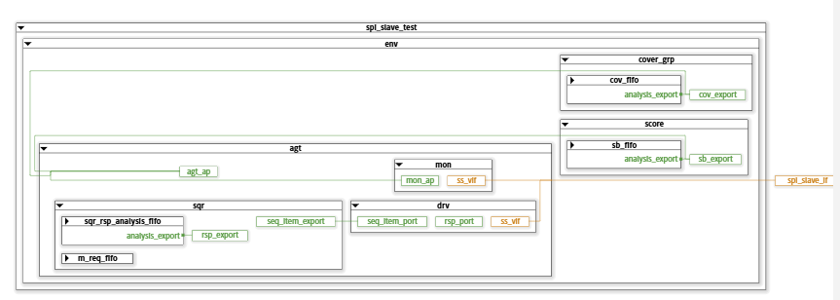

**Comment :** first top set the virtual interface in configuration data base ,then test get this virtual interface and set configuration data base with all interface then agent get this configuration object and use it to connect between driver and monitor with the interface of DUT , Driver ask sequencer if there is data from sequence item , if there is data take data and give it to interface then monitor get data from interface and give it to scoreboard to compare it with refrence model by using fifo to get sequence item and give it to scoreboard , the same way for collector get sequence item and cover if sequence done , then after the simulation done test raise object and end simulation .

1. **Design file**

module SLAVE (spi_slave_if.DUT ss_if);

localparam IDLE      = 3'b000;

localparam WRITE     = 3'b001;

localparam CHK_CMD   = 3'b010;

localparam READ_ADD  = 3'b011;

localparam READ_DATA = 3'b100;

reg [3:0] counter;

reg       received_address;

reg [2:0] cs, ns;

always @(posedge ss_if.clk) begin

    if (~ss_if.rst_n) begin

        cs <= IDLE;

    end

    else begin

        cs <= ns;

    end

end

always @(*) begin

    case (cs)

        IDLE : begin

            if (ss_if.SS_n)

                ns = IDLE;

            else

                ns = CHK_CMD;

        end

        CHK_CMD : begin

            if (ss_if.SS_n)

                ns = IDLE;

            else begin

                if (~ss_if.MOSI)

                    ns = WRITE;

                else begin

                      if (received_address)

                        ns = READ_DATA;

                    else

                        ns = READ_ADD;

                end

            end

        end

        WRITE : begin

            if (ss_if.SS_n)

                ns = IDLE;

            else

                ns = WRITE;

        end

        READ_ADD : begin

            if (ss_if.SS_n)

                ns = IDLE;

            else

                ns = READ_ADD;

        end

        READ_DATA : begin

            if (ss_if.SS_n)

                ns = IDLE;

            else

                ns = READ_DATA;

        end

    endcase

end

always @(posedge ss_if.clk) begin

    if (~ss_if.rst_n) begin

        ss_if.rx_data <= 0;

        ss_if.rx_valid <= 0;

        received_address <= 0;

        ss_if.MISO <= 0;

        counter<=0; // reset

    end

    else begin

        case (cs)

            IDLE : begin

                ss_if.rx_valid <= 0;

            end

            CHK_CMD : begin

                counter <= 10;

            end

            WRITE : begin

                if (counter > 0) begin

                    ss_if.rx_data[counter-1] <= ss_if.MOSI;

                    counter <= counter - 1;

                end

                else begin

                    ss_if.rx_valid <= 1;

                end

            end

            READ_ADD : begin

                if (counter > 0) begin

                    ss_if.rx_data[counter-1] <= ss_if.MOSI;

                    counter <= counter - 1;

                end

                else begin

                    ss_if.rx_valid <= 1;

                    received_address <= 1;

                end

            end

            READ_DATA : begin

                if (ss_if.tx_valid) begin

                    if (counter > 0) begin

                        ss_if.MISO <= ss_if.tx_data[counter-1];

                        counter <= counter - 1;

                    end

                    else begin

                        received_address <= 0;

                         ss_if.rx_valid <= 0;

                    end

                end

                else begin

                    if (counter > 0) begin // write data before going to read data

                        ss_if.rx_data[counter-1] <= ss_if.MOSI;

                        counter <= counter - 1;

                    end

                    else begin

                        ss_if.rx_valid <= 1;

                        counter <= 8;

                    end

                end

            end

        endcase

    end

end

// READ_ADD and READ_DATA is replaced

// counter not equal 0 at reset

 `ifdef SIM

*sequence write_add_seq;*

*(ss_if.SS_n==1) ##1 (ss_if.SS_n==0) ##1 (ss_if.MOSI == 0)[*3];*

*endsequence*

*sequence write_data_seq;*

*(ss_if.SS_n==1) ##1 (ss_if.SS_n==0) ##1 (ss_if.MOSI == 0)[*2] ##1(ss_if.MOSI==1);*

*endsequence*

*sequence read_add_seq;*

*(ss_if.SS_n==1) ##1 (ss_if.SS_n==0) ##1 (ss_if.MOSI == 1)[*2] ##1(ss_if.MOSI==0);*

*endsequence*

*sequence read_data_seq;*

*(ss_if.SS_n==1) ##1 (ss_if.SS_n==0) ##1 (ss_if.MOSI == 1)[*3];*

*endsequence*

*property chck_rx_valid;*

*@(posedge ss_if.clk) disable iff(~ss_if.rst_n)*

*(write_add_seq or write_data_seq or read_add_seq or read_data_seq) |=> ##9 ($rose(ss_if.rx_valid) && $rose(ss_if.SS_n)[->1]);*

*endproperty*

*property chck_reset ;*

*@(posedge ss_if.clk)   (~ss_if.rst_n) |=>(ss_if.MISO ==0 && ss_if.rx_valid==0 && ss_if.rx_data==0);*

*endproperty*

*property chck_state_idle;*

*@(posedge ss_if.clk) disable iff(~ss_if.rst_n) (cs==IDLE && !ss_if.SS_n) |=>(cs==CHK_CMD);*

*endproperty*

*property chck_state_write;*

*@(posedge ss_if.clk) disable iff(~ss_if.rst_n) (cs==CHK_CMD && !ss_if.SS_n && !ss_if.MOSI) |=>  (cs==WRITE);*

*endproperty*

*property chck_state_read_add;*

*@(posedge ss_if.clk) disable iff(~ss_if.rst_n)  (cs==CHK_CMD && !ss_if.SS_n && ss_if.MOSI && !received_address) |=>(cs==READ_ADD);*

*endproperty*

*property chck_state_read_data;*

*@(posedge ss_if.clk) disable iff(~ss_if.rst_n)  (cs==CHK_CMD && !ss_if.SS_n && ss_if.MOSI && received_address) |=>(cs==READ_DATA);*

*endproperty*

*property chck_state_write_to_idle;*

*@(posedge ss_if.clk)  (cs==WRITE &&(~ss_if.rst_n)) |=> (cs==IDLE);*

*endproperty*

*property chck_state_read_add_to_idle;*

*@(posedge ss_if.clk)  (cs==READ_ADD && (~ss_if.rst_n)) |=> (cs==IDLE);*

*endproperty*

*property chck_state_read_datato_idle;*

*@(posedge ss_if.clk)  (cs==READ_DATA && (~ss_if.rst_n)) |=> (cs==IDLE);*

*endproperty*

*assert property (chck_reset);*

*assert property (chck_rx_valid);*

*assert property (chck_state_idle);*

*assert property (chck_state_write);*

*assert property (chck_state_read_add);*

*assert property (chck_state_read_data);*

*assert property (chck_state_write_to_idle);*

*assert property (chck_state_read_add_to_idle);*

*assert property (chck_state_read_datato_idle);*

*cover property (chck_reset);*

*cover property (chck_rx_valid);*

*cover property (chck_state_idle);*

*cover property (chck_state_write);*

*cover property (chck_state_read_add);*

*cover property (chck_state_read_data);*

*cover property (chck_state_write_to_idle);*

*cover property (chck_state_read_add_to_idle);*

*cover property (chck_state_read_datato_idle);*

`endif

Endmodule

1. **Design Bugs**

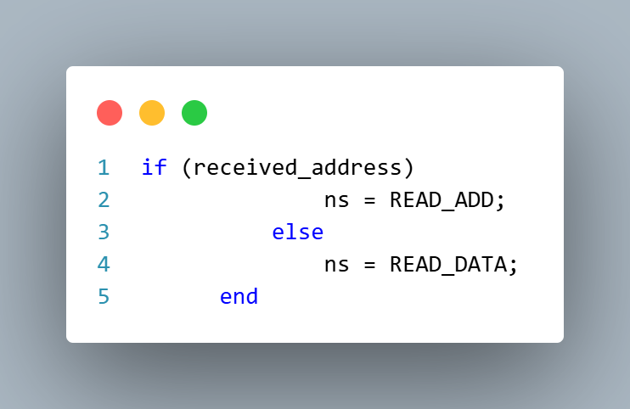

Figure bug 1

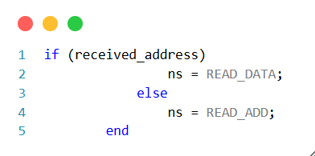

Figure bug1 fixed

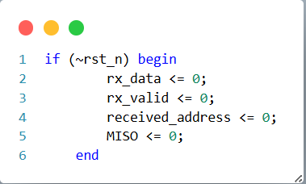

Figure bug 2

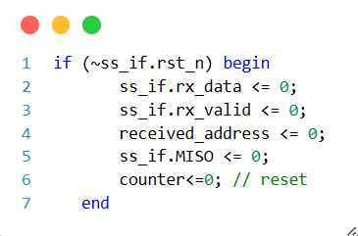

Figure bug2 fixed

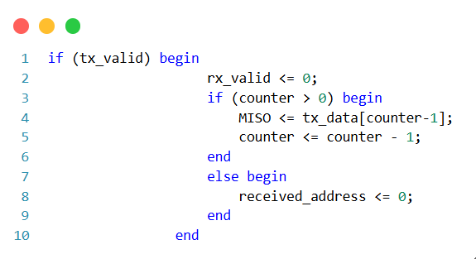

Figure bug 3

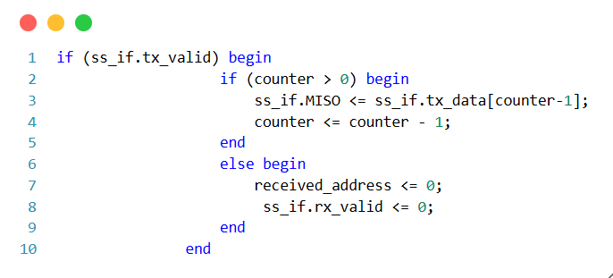

Figure bug 3 fixed

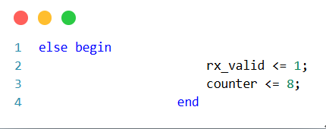

Figure bug 4

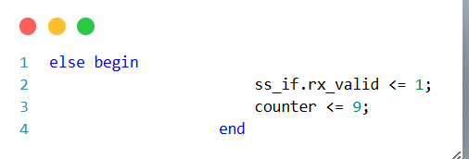

Figure bug4 fixed

1. **Refrence model file**

module SPI_Slave(MOSI,SS_n,clk,rst_n,rx_data,tx_valid,tx_data,MISO,rx_valid);

input MOSI,SS_n,clk,rst_n,tx_valid;

input [7:0] tx_data;

output reg MISO,rx_valid;

output  reg [9:0] rx_data;

parameter IDLE=3'b000;

parameter CHK_CMD=3'b001;

parameter WRITE=3'b010;

parameter READ_ADD=3'b011;

parameter  READ_DATA=3'b100;

reg ADDRESS_read; // this is signal to increment when  reading an address

reg[3:0] counter;

reg [2:0] cs ,ns;

always@(posedge clk) begin

    if(~rst_n)

     cs<=IDLE;

     else

     cs<=ns;

end

always@(*) begin

    case(cs)

    IDLE: begin

        if(SS_n)

        ns=IDLE;

        else

        ns=CHK_CMD;

    end

   CHK_CMD : begin

    if (SS_n)

    ns = IDLE;

    else begin

     if( ~MOSI) begin

        ns=WRITE;

    end

    else begin

        casex(ADDRESS_read)

        1'b0 : ns=READ_ADD;

        1'b1: ns=READ_DATA;

        1'bx: ns=READ_ADD;

        endcase

    end

   end

   end

   WRITE: begin

     if(SS_n==0 )

     ns=WRITE;

     else begin

        ns=IDLE;

     end

   end

   READ_ADD :  begin

    if(SS_n==0) begin

    ns=READ_ADD;

    end

    else begin

        ns=IDLE;

    end

   end

   READ_DATA : begin

    if(SS_n==0)

    ns=READ_DATA;

    else begin

        ns=IDLE;

    end

   end

    endcase

end

always @(posedge clk) begin

      if (~rst_n) begin

        rx_data <= 0;

        rx_valid <= 0;

        ADDRESS_read<= 0;

        MISO <= 0;

    end

    else begin

   case(cs)

    IDLE: rx_valid<=0;

    CHK_CMD : begin

         counter<=10;

    end

    WRITE  : begin

        if(counter>0) begin

        rx_data[counter-1]<=MOSI;

        counter<=counter-1;

        end

        else begin

            rx_valid<=1;

        end

    end

    READ_ADD : begin

         if(counter>0) begin

        rx_data[counter-1]<=MOSI;

        counter<=counter-1;

        end

        else begin

            rx_valid<=1;

            ADDRESS_read<=1;

        end

    end

   READ_DATA : begin

    if (tx_valid) begin

        if(counter>0) begin

            MISO<=tx_data[counter-1];

             counter<=counter-1;

        end

         else begin

                ADDRESS_read <= 0;

                rx_valid<=0;

         end

    end

    else begin

       if(counter>0) begin

        rx_data[counter-1]<=MOSI;

        counter<=counter-1;

       end

       else begin

        rx_valid<=1;

        counter<=9;

       end

    end

   end

   endcase

    end

end

endmodule

1. **Interface file**

interface spi_slave_if (clk);

  input  bit clk;

 logic           MOSI, rst_n, SS_n, tx_valid;

 logic      [7:0] tx_data;

logic [9:0] rx_data,rx_data_ref;

logic       rx_valid, MISO,MISO_ref , rx_valid_ref;

modport DUT(input clk,MOSI,rst_n,SS_n,tx_data,tx_valid, output MISO,rx_data,rx_valid);

endinterface : spi_slave_if

1. **Top file**

import uvm_pkg::*;

`include "uvm_macros.svh"

import spi_slave_test_pkg::*;

import spi_slave_seq_item_package::*;

import shared_pkg::*;

module top();

    bit clk;

    initial begin

      forever #2 clk=~clk;

    end

    spi_slave_if ss_if(clk);

    SLAVE DUT(ss_if);

    SPI_Slave dut(ss_if.MOSI,ss_if.SS_n,ss_if.clk,ss_if.rst_n,ss_if.rx_data_ref,ss_if.tx_valid,ss_if.tx_data,ss_if.MISO_ref,ss_if.rx_valid_ref);

    initial begin

      uvm_config_db #(virtual spi_slave_if) :: set(null,"uvm_test_top","SPI_IF",ss_if);

    run_test ("spi_slave_test");

    end

endmodule

1. **Sequence item file**

package spi_slave_seq_item_package;

import uvm_pkg::*;

 `include "uvm_macros.svh"

import shared_pkg::*;

class spi_slave_seq_item extends uvm_sequence_item;

  `uvm_object_utils(spi_slave_seq_item);

 rand logic [7:0] tx_data;

 logic [9:0] rx_data ,rx_data_ref;

 logic rx_valid, MISO,MISO_ref ,rx_valid_ref;

  logic MOSI;

 rand logic SS_n;

 rand logic rst_n;

 rand logic tx_valid;

 rand bit[0:10] array_rand;

  function new(string name= "spi_slave_seq_item");

     super.new(name);

 endfunction

   //reset

    constraint reset

    {

      rst_n  dist { 1:/98 , 0:/2};

    }

    //SS_n for all cases

    constraint serial_comm_all_cases

    {

      if(  array_rand[0:2] inside {3'b000, 3'b001, 3'b110} && counter_allcases%14 !=0) {

         SS_n==0;

      }

       else

        {

          SS_n==1;

        }

    }

    //SS_n for read data

    constraint serial_comm_read_data{

     if(  array_rand[0:2] inside {3'b111} && counter_read%24 !=0) {

         SS_n==0;

      }

       else

        {

          SS_n==1;

        }

    }

    //tx_valid for read data

    constraint trans_ram

    {

            if (array_rand[0:2] == 3'b111  && counter_read==23)

              {

                tx_valid==1;

              }

              if(array_rand[0:2] != 3'b111)

                {

                  tx_valid==0;

                }

    }

    // array_rand for all cases

    constraint mosi_in

    {

      if (SS_n_prev && !SS_n)

      array_rand[0:2] inside {3'b000, 3'b001, 3'b110 , 3'b111};

    }

    function void post_randomize;

      SS_n_prev=SS_n;

       if(counter_allcases<11 )

        MOSI=array_rand[counter_allcases];

    endfunction

    function update_counter_allcases;

     counter_allcases++;

    if (counter_allcases==14 )

    counter_allcases=0;

    endfunction

    function update_counter_read;

     counter_read++;

    if (counter_read==24 )

    counter_read=0;

    endfunction

 function string convert2string();

 return $sformatf("%s reset = 0b%0b , mosi=%b , miso=%b , ss_n = %b ",super.convert2string(),rst_n,MOSI,MISO,SS_n);

 endfunction

 function string convert2string_stimulus();

 return $sformatf("reset = 0b%0b , mosi=%b , ss_n = %b ",rst_n,MOSI,SS_n);

 endfunction

endclass

endpackage

1. **Main sequence file**

package spi_slave_main_sequence_package;

import uvm_pkg::*;

`include "uvm_macros.svh"

import spi_slave_seq_item_package::*;

import shared_pkg::*;

class spi_slave_main_sequence extends  uvm_sequence #(spi_slave_seq_item);

 `uvm_object_utils(spi_slave_main_sequence);

 spi_slave_seq_item seq_item_main;

 function new(string name= "spi_slave_main_sequence");

     super.new(name);

 endfunction

 task body ;

 seq_item_main= spi_slave_seq_item :: type_id :: create("seq_item_main");

 repeat(1000) begin

 start_item(seq_item_main);

 seq_item_main.reset.constraint_mode(1);

 seq_item_main.serial_comm_all_cases.constraint_mode(1);

 seq_item_main.mosi_in.constraint_mode(1);

 seq_item_main.serial_comm_read_data.constraint_mode(0);

 seq_item_main.trans_ram.constraint_mode(0);

 if(counter_allcases==0) begin

  seq_item_main.array_rand.rand_mode(1);

    $display("array_rand=%b , time =%t ,conter=%d",seq_item_main.array_rand,$time,counter_allcases);

 end

 else begin

  seq_item_main.array_rand.rand_mode(0);

 end

 assert (seq_item_main.randomize() with {seq_item_main.array_rand[0:2] inside {3'b000,3'b001,3'b110};} );

 seq_item_main.update_counter_allcases;

 finish_item(seq_item_main);

 end

 repeat(1000) begin

 start_item(seq_item_main);

 seq_item_main.reset.constraint_mode(1);

 seq_item_main.serial_comm_all_cases.constraint_mode(0);

 seq_item_main.mosi_in.constraint_mode(0);

 seq_item_main.serial_comm_read_data.constraint_mode(1);

 seq_item_main.trans_ram.constraint_mode(1);

 if(counter_read==0) begin

  seq_item_main.array_rand.rand_mode(1);

    $display("array_rand=%b , time =%t ,conter=%d",seq_item_main.array_rand,$time,counter_read);

 end

 else begin

  seq_item_main.array_rand.rand_mode(0);

 end

 assert (seq_item_main.randomize() with {seq_item_main.array_rand[0:2] inside {3'b111};} );

 seq_item_main.update_counter_read;

 finish_item(seq_item_main);

 end

 endtask

 endclass

endpackage

1. **Reset sequence file**

package spi_slave_reset_sequence_package;

import uvm_pkg::*;

`include "uvm_macros.svh"

import spi_slave_seq_item_package::*;

class spi_slave_reset_sequence extends  uvm_sequence #(spi_slave_seq_item);

 `uvm_object_utils(spi_slave_reset_sequence);

 spi_slave_seq_item seq_item;

 function new(string name= "spi_slave_reset_sequence");

     super.new(name);

 endfunction

 task body ;

 seq_item= spi_slave_seq_item :: type_id :: create("seq_item");

 start_item(seq_item);

        seq_item.rst_n=1;

        seq_item.rx_valid=0;

        seq_item.tx_valid=0;

        seq_item.SS_n=1;

 finish_item(seq_item);

 endtask

endclass

endpackage

1. **Sequencer file**

package spi_slave_sequencer_package ;

import uvm_pkg::*;

`include "uvm_macros.svh"

import spi_slave_seq_item_package::*;

class spi_slave_sequencer extends uvm_sequencer #(spi_slave_seq_item);

  `uvm_component_utils(spi_slave_sequencer)

  function new(string name= "spi_slave_sequencer",uvm_component parent=null);

    super.new(name,parent);

  endfunction

endclass

endpackage

1. **Configuration object file**

package spi_slave_config_pkg;

    import uvm_pkg::*;

    `include "uvm_macros.svh"

class spi_slave_config extends uvm_object;

    `uvm_object_utils(spi_slave_config) // factory store name of class

   virtual spi_slave_if ss_vif; //  create interface inside configration class

 function new(string name= "spi_slave_config");

     super.new(name);

 endfunction

endclass

endpackage

1. **Shared pkg**

package shared_pkg;

int counter_allcases =0  ;

int counter_read=0;

 logic SS_n_prev=1;

endpackage

1. **Driver**

 package spi_slave_driver_pkg;

 import uvm_pkg::*;

    `include "uvm_macros.svh"

    import spi_slave_seq_item_package::*;

    import shared_pkg ::*;

class spi_slave_driver extends uvm_driver #(spi_slave_seq_item);

 `uvm_component_utils(spi_slave_driver);

 virtual spi_slave_if ss_vif;

 spi_slave_seq_item seq_item;

 function new(string name ="spi_slave_driver",uvm_component parent =null);

    super.new(name,parent);

    endfunction

    task run_phase(uvm_phase phase);

    super.run_phase(phase);

    forever begin

      seq_item =  spi_slave_seq_item :: type_id :: create ( "seq_item");

      seq_item_port.get_next_item(seq_item);

      ss_vif.rst_n=seq_item.rst_n;

      ss_vif.SS_n=seq_item.SS_n;

      ss_vif.MOSI=seq_item.MOSI;

      ss_vif.tx_valid=seq_item.tx_valid;

      ss_vif.tx_data=seq_item.tx_data;

      @(negedge ss_vif.clk);

      seq_item_port.item_done();

      `uvm_info ("run_phase",seq_item.convert2string_stimulus(),UVM_HIGH)

    end

    endtask

endclass

 endpackage

1. **Monitor**

package spi_slave_monitor_pkg;

 import uvm_pkg::*;

    `include "uvm_macros.svh"

    import  spi_slave_seq_item_package::*;

    import shared_pkg ::*;

class spi_slave_monitor extends uvm_monitor;

 `uvm_component_utils(spi_slave_monitor);

 virtual spi_slave_if ss_vif;

spi_slave_seq_item seq_item;

 uvm_analysis_port #(spi_slave_seq_item) mon_ap;

  function new(string name ="spi_slave_monitor",uvm_component parent =null);

    super.new(name,parent);

    endfunction

            function void build_phase( uvm_phase phase);

            super.build_phase(phase);

            mon_ap = new("mon_ap", this);

        endfunction

    task run_phase (uvm_phase phase);

    super.run_phase(phase);

    forever begin

        seq_item=spi_slave_seq_item::type_id::create("seq_item");

        @(negedge ss_vif.clk);

        seq_item.rst_n=ss_vif.rst_n;

        seq_item.MOSI=ss_vif.MOSI;

        seq_item.SS_n=ss_vif.SS_n;

        seq_item.MISO=ss_vif.MISO;

        seq_item.MISO_ref=ss_vif.MISO_ref;

        seq_item.tx_valid=ss_vif.tx_valid;

        seq_item.tx_data=ss_vif.tx_data;

        seq_item.rx_valid=ss_vif.rx_valid;

        seq_item.rx_data=ss_vif.rx_data;

        seq_item.rx_valid_ref=ss_vif.rx_valid_ref;

         seq_item.rx_data_ref=ss_vif.rx_data_ref;

        mon_ap.write(seq_item);

        `uvm_info ("run_phase",seq_item.convert2string_stimulus(),UVM_HIGH)

    end

    endtask

endclass

endpackage

1. **Agent**

package spi_slave_agent_pkg;

  import uvm_pkg::*;

  `include "uvm_macros.svh"

  import  spi_slave_seq_item_package::*;

  import spi_slave_config_pkg::*;

  import  spi_slave_driver_pkg::*;

  import spi_slave_monitor_pkg::*;

  import spi_slave_sequencer_package::*;

  class spi_slave_agent extends uvm_agent;

    `uvm_component_utils(spi_slave_agent)

    spi_slave_seq_item seq_item;

    spi_slave_config           s_cfg;

    spi_slave_driver       drv;

   spi_slave_sequencer sqr;

   spi_slave_monitor       mon;

    uvm_analysis_port #(spi_slave_seq_item) agt_ap;

    function new(string name = "spi_slave_agent", uvm_component parent = null);

      super.new(name, parent);

    endfunction

    function void build_phase(uvm_phase phase);

      super.build_phase(phase);

      if (!uvm_config_db#(spi_slave_config)::get(this, "", "CFG", s_cfg)) begin

        `uvm_fatal("build_phase", "unable to get configuration object")

      end

      sqr = spi_slave_sequencer::type_id::create("sqr", this);

      drv = spi_slave_driver::type_id::create("drv", this);

      mon = spi_slave_monitor::type_id::create("mon", this);

      agt_ap = new("agt_tb",this);

    endfunction

    function void connect_phase(uvm_phase phase);

      super.connect_phase(phase);

      drv.ss_vif = s_cfg.ss_vif;

      mon.ss_vif = s_cfg.ss_vif;

      drv.seq_item_port.connect(sqr.seq_item_export);

     mon.mon_ap.connect(agt_ap);

    endfunction

  endclass

endpackage

**16. Scoreboard**

package spi_slave_scoreboard_pkg;

 import uvm_pkg::*;

    `include "uvm_macros.svh"

    import  spi_slave_seq_item_package::*;

    class spi_slave_scoreboard extends uvm_scoreboard ;

     `uvm_component_utils(spi_slave_scoreboard);

     uvm_analysis_export #(spi_slave_seq_item) sb_export;

     uvm_tlm_analysis_fifo  #(spi_slave_seq_item) sb_fifo;

    spi_slave_seq_item sq_item_sb;

     int err_count=0;

     int correct_count=0;

     function new(string name ="spi_slave_scoreboard",uvm_component parent =null);

    super.new(name,parent);

    endfunction

    function void build_phase (uvm_phase phase);

    super.build_phase(phase);

    sb_export = new("sb_export",this);

    sb_fifo = new("sb_fifo" , this);

    endfunction

    function void connect_phase (uvm_phase phase);

    super.connect_phase(phase);

    sb_export.connect(sb_fifo.analysis_export);

    endfunction

    task run_phase (uvm_phase phase);

  super.run_phase(phase);

  forever begin

  sb_fifo.get(sq_item_sb);

  if (sq_item_sb.MISO != sq_item_sb.MISO_ref || sq_item_sb.rx_valid !=sq_item_sb.rx_valid_ref || sq_item_sb.rx_data!=sq_item_sb.rx_data_ref) begin

    `uvm_error("run_phase",$sformatf("Comparison failed, Transaction received by the DUT: %s While the reference out:0b%0b",

sq_item_sb.convert2string(),sq_item_sb.MISO_ref))

    err_count++;

  end

  else begin

    `uvm_info("run_phase",$sformatf("Correct ALU out: %s", sq_item_sb.convert2string()), UVM_HIGH)

    correct_count++;

  end

  end

endtask

function void report_phase(uvm_phase phase) ;

super. report_phase (phase) ;

 `uvm_info("report_phase", $sformatf("Total successful transactions: %0d", correct_count), UVM_MEDIUM);

`uvm_info("report_phase", $sformatf("Total failed transactions: %0d", err_count), UVM_MEDIUM);

endfunction

    endclass

 endpackage

**17. collector**

package  spi_slave_collector_package ;

import uvm_pkg::*;

`include "uvm_macros.svh"

 import  spi_slave_seq_item_package::*;

 import shared_pkg::*;

class spi_slave_coverage extends uvm_component;

  `uvm_component_utils(spi_slave_coverage)

  uvm_analysis_export #(spi_slave_seq_item) cov_export;

  uvm_tlm_analysis_fifo #(spi_slave_seq_item) cov_fifo;

  spi_slave_seq_item seq_item_cov;

  covergroup covcode ;

  reciver_data: coverpoint seq_item_cov.rx_data[9:8];

  ss_n_allcases : coverpoint seq_item_cov.SS_n

  {

    bins trans_all_cases= (1 => 0[*13] =>1) ;

  }

  ss_n_read_data : coverpoint seq_item_cov.SS_n

  {

     bins trans_read= (1 => 0[*23] =>1) ;

  }

  ss_n : coverpoint seq_item_cov.SS_n

  {

    bins ss_n_val={0};

  }

  mosi: coverpoint seq_item_cov.MOSI

  {

    bins write_add = (0=>0=>0);

    bins write_data = (0=>0=>1);

    bins read_add = (1=>1=>0);

    bins read_data =(1=>1=>1);

  }

cross_mosi_ss_n : cross mosi,ss_n

  {

     option.cross_auto_bin_max=0;

     bins ss_n_low_write_add = binsof(ss_n.ss_n_val)  && binsof(mosi.write_add);

     bins ss_n_low_write_data = binsof(ss_n.ss_n_val)  && binsof(mosi.write_data);

     bins ss_n_low_read_add = binsof(ss_n.ss_n_val)  && binsof(mosi.read_add);

     bins ss_n_low_read_data = binsof(ss_n.ss_n_val)  && binsof(mosi.read_data);

  }

  endgroup

  function new(string name = "spi_slave_coverage", uvm_component parent = null);

    super.new(name, parent);

    covcode=new();

  endfunction

  function void build_phase(uvm_phase phase);

    super.build_phase(phase);

    cov_export = new("cov_export", this);

    cov_fifo   = new("cov_fifo", this);

  endfunction

  function void connect_phase(uvm_phase phase) ;

    super.connect_phase(phase);

    cov_export.connect(cov_fifo.analysis_export);

  endfunction

  task run_phase(uvm_phase phase);

  super.run_phase(phase);

  forever begin

    cov_fifo.get(seq_item_cov);

    covcode.sample();

  end

  endtask

endclass

endpackage

**18. Environment**

package spi_slave_env_pkg;

import uvm_pkg::*;

`include "uvm_macros.svh"

import spi_slave_agent_pkg::*;

import spi_slave_scoreboard_pkg::*;

import spi_slave_collector_package::*;

class spi_slave_env extends uvm_env;

      `uvm_component_utils(spi_slave_env);

      spi_slave_scoreboard score;

       spi_slave_coverage cover_grp;

     spi_slave_agent agt;

      function new(string name ="spi_slave_env",uvm_component parent =null);

    super.new(name,parent);

    endfunction

   function void build_phase (uvm_phase phase);

   super.build_phase(phase);

   agt = spi_slave_agent :: type_id ::create("agt",this);

   score =   spi_slave_scoreboard :: type_id :: create("score",this);

   cover_grp = spi_slave_coverage  ::type_id ::create("cover_grp",this);

   endfunction

   function void connect_phase (uvm_phase phase);

   agt.agt_ap.connect(score.sb_export);

   agt.agt_ap.connect(cover_grp.cov_export);

   endfunction

endclass

endpackage

**19. Test**

package spi_slave_test_pkg;

import uvm_pkg::*;

`include "uvm_macros.svh"

import spi_slave_env_pkg::*;

 import spi_slave_reset_sequence_package::*;

 import spi_slave_main_sequence_package::*;

import spi_slave_config_pkg ::*;

class spi_slave_test extends uvm_test;

    `uvm_component_utils(spi_slave_test);

   spi_slave_env  env;

   spi_slave_config   s_cfg;

    spi_slave_reset_sequence rst_seq;

   spi_slave_main_sequence main_seq;

    function new(string name ="spi_slave_test",uvm_component parent =null);

    super.new(name,parent);

    endfunction

    function void build_phase (uvm_phase phase);

    super.build_phase(phase);

    env =spi_slave_env :: type_id :: create("env",this);

    s_cfg = spi_slave_config   :: type_id :: create ("s_cfg");

    rst_seq= spi_slave_reset_sequence :: type_id :: create ("rst_seq");

    main_seq=spi_slave_main_sequence :: type_id :: create("main_seq");

    if(!uvm_config_db #(virtual spi_slave_if) :: get(this,"","SPI_IF",s_cfg.ss_vif))

    `uvm_fatal("build_phase","Test - unable to get the virtual interface");

    uvm_config_db #(spi_slave_config) :: set(this,"*","CFG",s_cfg);

    endfunction

    task run_phase(uvm_phase phase);

    super.run_phase(phase);

    phase.raise_objection(this);

     `uvm_info("run_phase","reset_asserted",UVM_LOW)

     rst_seq.start(env.agt.sqr);

     `uvm_info("run_phase","reset_deasserted",UVM_LOW)

     `uvm_info ("run_phase","stimulus generation begin",UVM_LOW)

      main_seq.start(env.agt.sqr);

       `uvm_info ("run_phase","stimulus generation done",UVM_LOW)

    phase.drop_objection(this);

    endtask

endclass: spi_slave_test

endpackage

**20. Src_file**

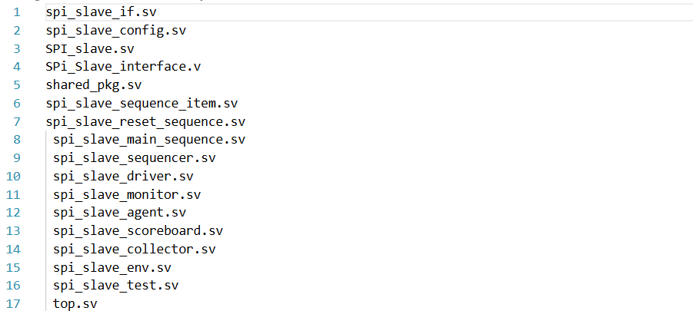

**21. Do file**

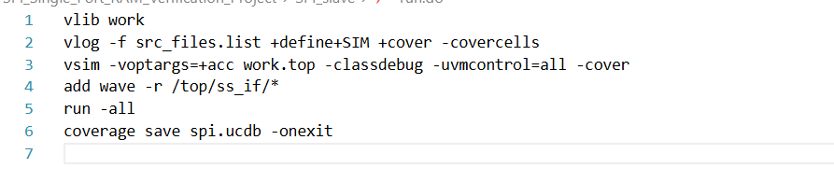

**22. Functional coverage**

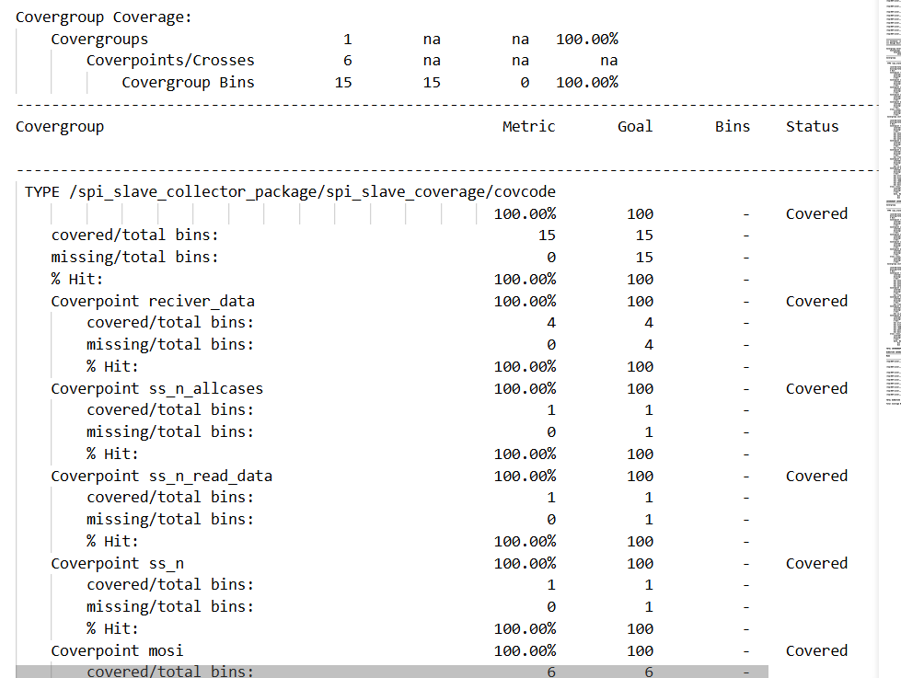

**23. Code coverage**

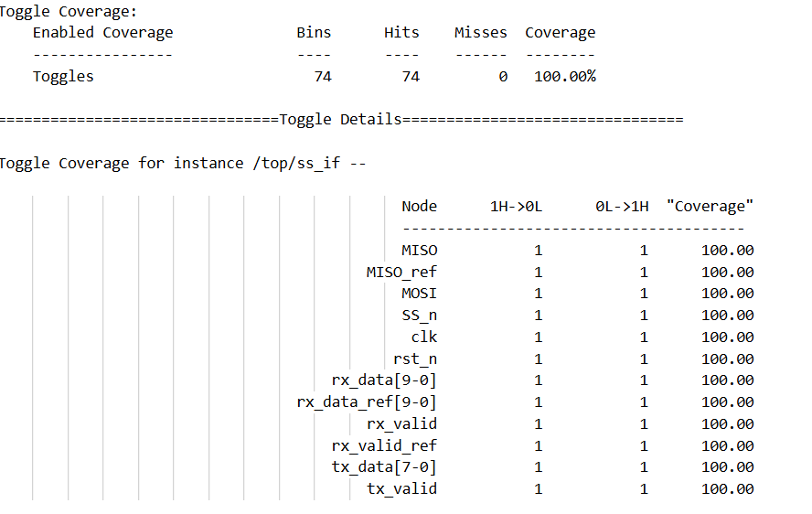

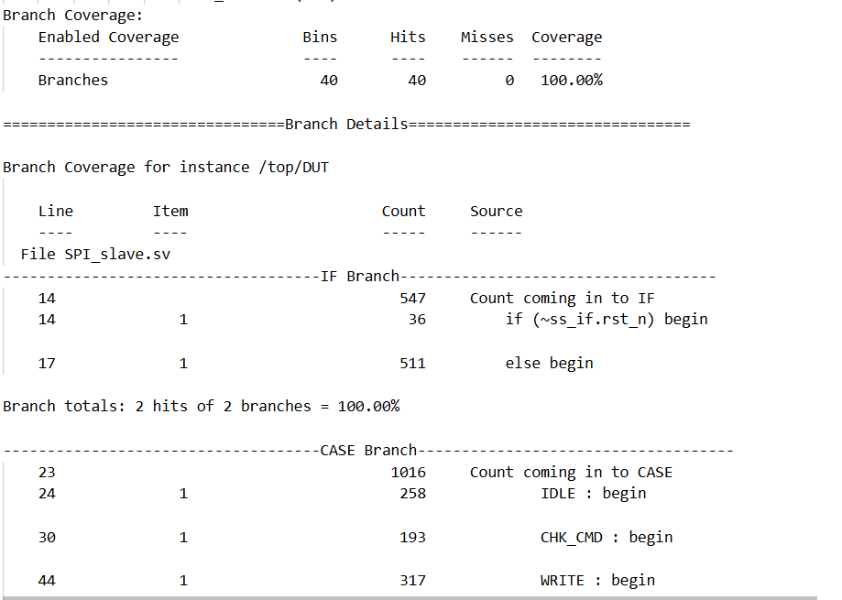

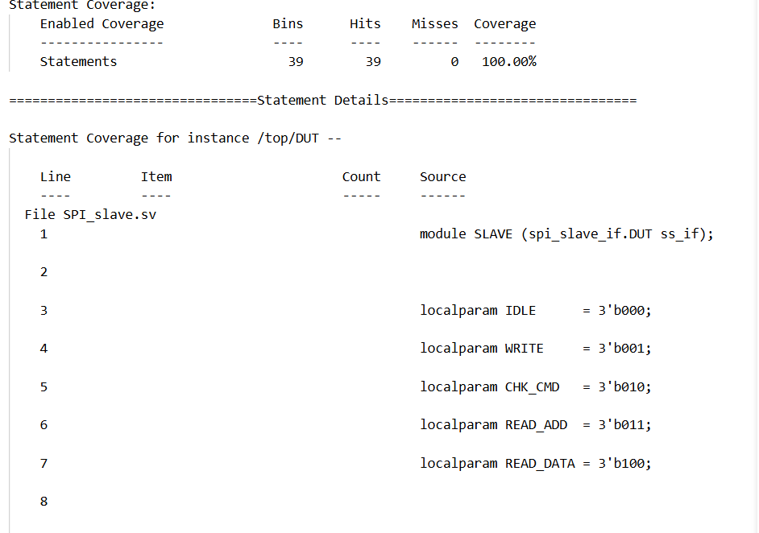

**24. Assertion coverage**

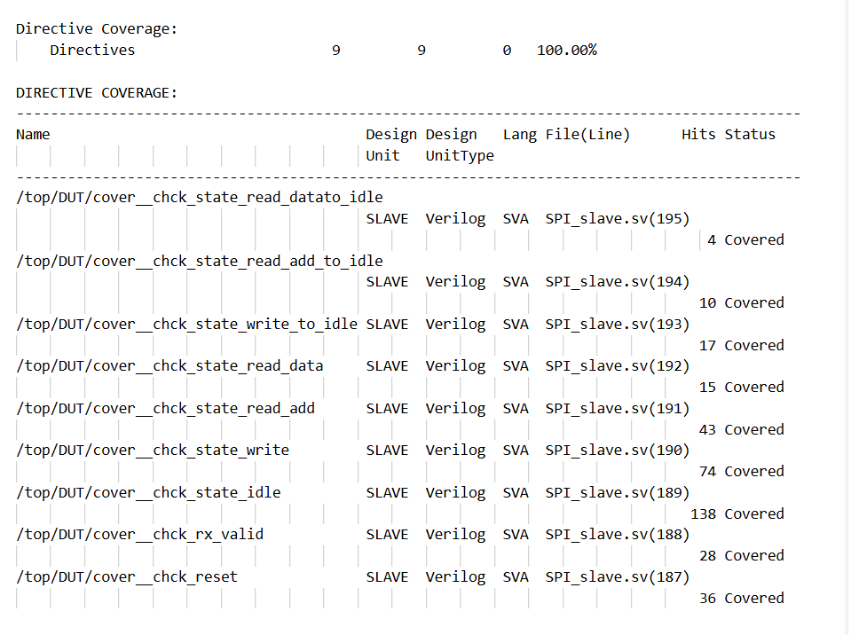

**25. Questasim snippets**

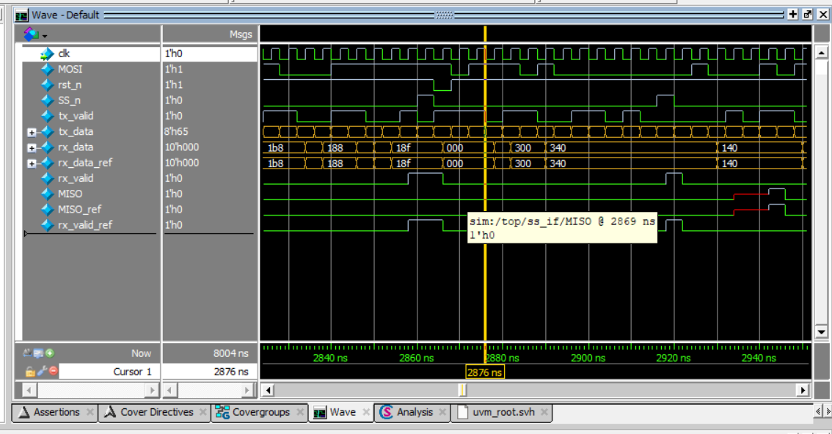

Figure when ss_n is deasserted mosi read_add sequence (110)

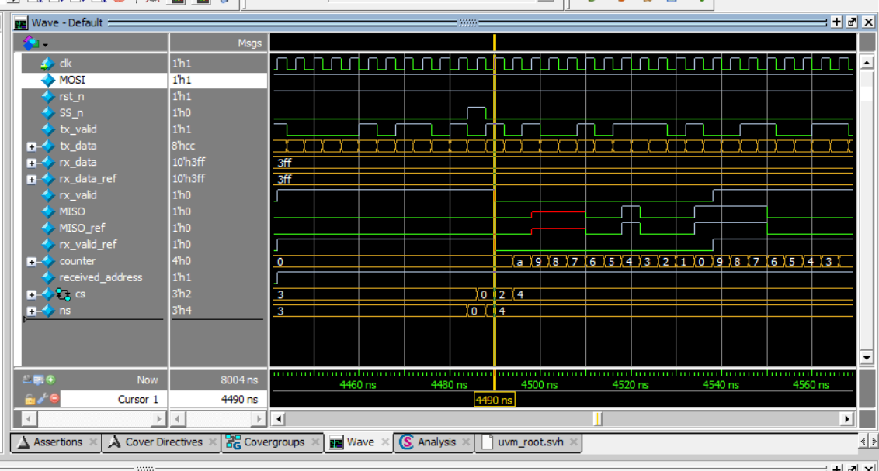

Figure when ss_n is deasserted mosi read_data sequence (111)

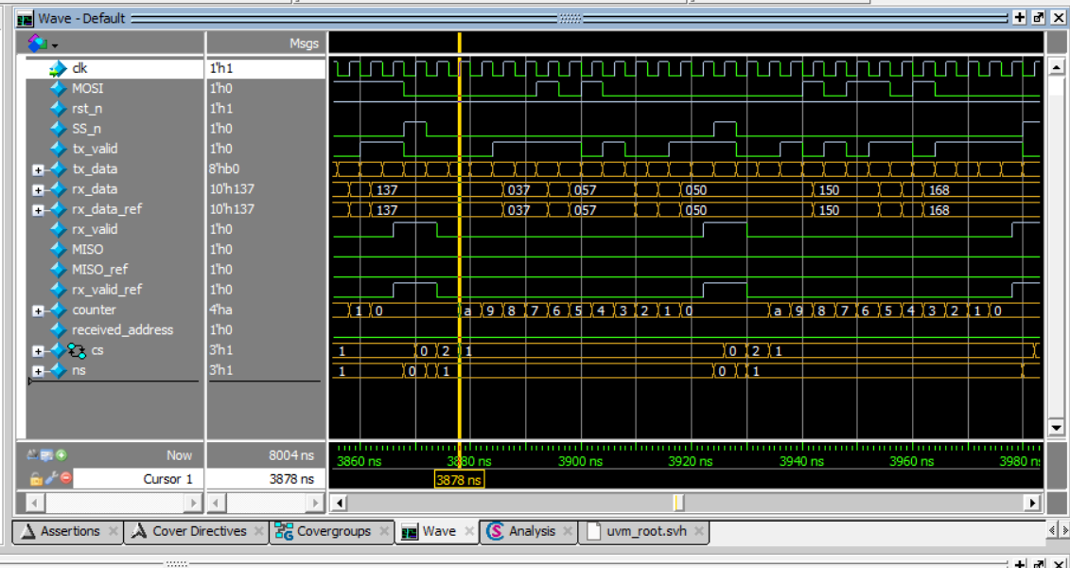

Figure when ss_n is deasserted mosi write_add sequence (000)

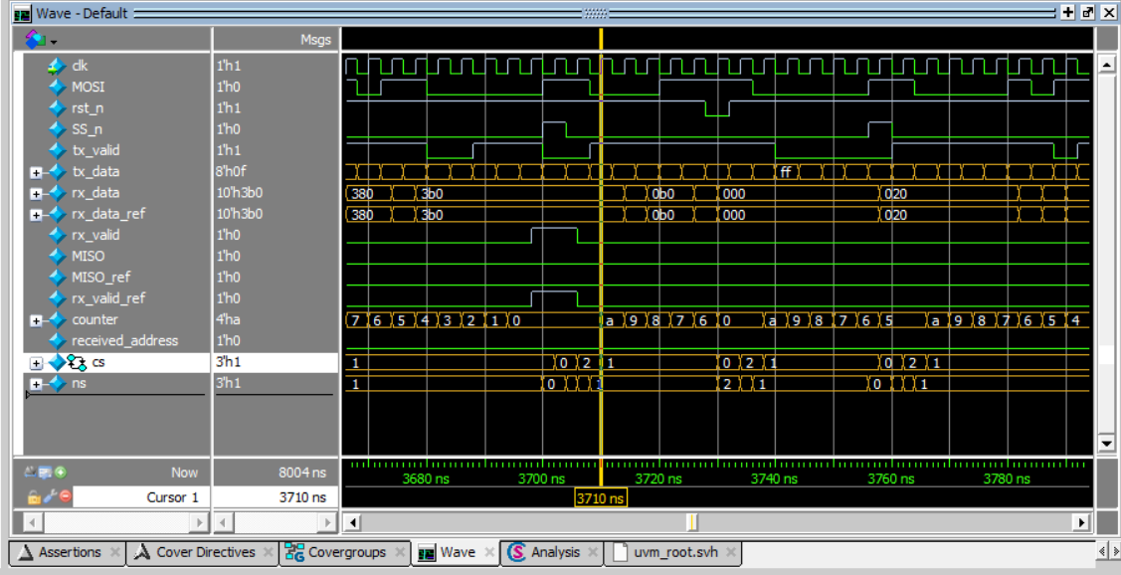

Figure when ss_n is deasserted mosi write_data sequence (001)

**26. Table of assertions with features**

|  |  |
| --- | --- |
| **Feature** | **Assertion** |
| Whenever the rst is asserted, MISO , rx_valid , rx_data is low | @(posedge ss_if.clk)   (~ss_if.rst_n) |=>(ss_if.MISO ==0 && ss_if.rx_valid==0 && ss_if.rx_data==0); |
| Whenever the current state is idle and SS_n is low so current state will be CHCK_CMD in next cycle and reset is high | @(posedge ss_if.clk) disable iff(~ss_if.rst_n) (cs==IDLE && !ss_if.SS_n) |=>(cs==CHK_CMD); |
| Whenever the current state CHCK_CMD and SS_n is low and mosi is low so current state will be WRITE in next cycle and reset is high | @(posedge ss_if.clk) disable iff(~ss_if.rst_n) (cs==CHK_CMD && !ss_if.SS_n && !ss_if.MOSI) |=>  (cs==WRITE); |
| Whenever the current state CHCK_CMD and SS_n is low and mosi is high and received_add is low so current state will be WRITE in next cycle and reset is high | @(posedge ss_if.clk) disable iff(~ss_if.rst_n)  (cs==CHK_CMD && !ss_if.SS_n && ss_if.MOSI && !received_address) |=>(cs==READ_ADD); |
| Whenever the current state CHCK_CMD and SS_n is low and mosi is high and received_add is high so current state will be WRITE in next cycle and reset is high | @(posedge ss_if.clk) disable iff(~ss_if.rst_n)  (cs==CHK_CMD && !ss_if.SS_n && ss_if.MOSI && received_address) |=>(cs==READ_DATA); |
| Whenever the rst is asserted and current state is WRITE , the current state will be IDEAL in next clock cycle | @(posedge ss_if.clk)  (cs==WRITE &&(~ss_if.rst_n)) |=> (cs==IDLE); |
| Whenever the rst is asserted and current state is READ_ADD , the current state will be IDEAL in next clock cycle | @(posedge ss_if.clk)  (cs==READ_ADD && (~ss_if.rst_n)) |=> (cs==IDLE); |
| Whenever the rst is asserted and current state is READ_DATA , the current state will be IDEAL in next clock cycle | @(posedge ss_if.clk)  (cs==READ_DATA && (~ss_if.rst_n)) |=> (cs==IDLE); |
| Whenever SS_n is deasserted and wite_add or write_data or read_add or read_data sequence done then rx_valid will assert and SS_n will assert to end communication | @(posedge ss_if.clk) disable iff(~ss_if.rst_n) (write_add_seq or write_data_seq or read_add_seq or read_data_seq) |=> ##9 ($rose(ss_if.rx_valid) && $rose (ss_if.SS_n)[->1]); |

***Sequence which I mentioned in last row :***

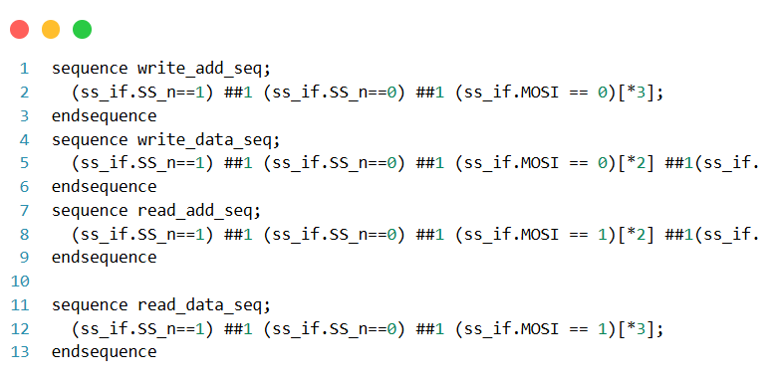

***2-RAM:***

|  |  |
| --- | --- |
| Feature | Assertion |
| When rst_n is asserted, dout & tx_valid are low | (@(posedge clk) (!rst_n) |=> (dout == 0) && (tx_valid == 0)) |
| When din[9:8] = 11 and rx_valid is asserted, tx_valid should be high and should eventually fall. | @(posedge clk) disable iff(!rst_n)  ((din[8] && din[9]) && rx_valid) |=> (tx_valid == 1) |=> $fell(tx_valid)[->1]) |
| When din[9:8] = 10, tx_valid should be low. | (@(posedge clk) disable iff(!rst_n) (!(din[8] && din[9])) |=> (tx_valid == 0)) |
| When din[9:8] = 00 which is a write address instruction, there should eventually be a write data instruction din[9:8] = 01 | (@(posedge clk) disable iff(!rst_n) ((!din[8] && !din[9])) |=> (din[8] && !din[9])[->1]); |
| When din[9:8] = 10 which is a read address instruction, there should eventually be a read data instruction din[9:8] = 11 | (@(posedge clk) disable iff(!rst_n) ((!din[8] && din[9])) |=> (din[8] && din[9])[->1]); |

Ram Uvm architecture :

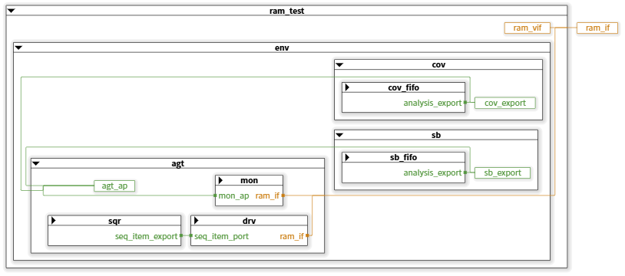

Top: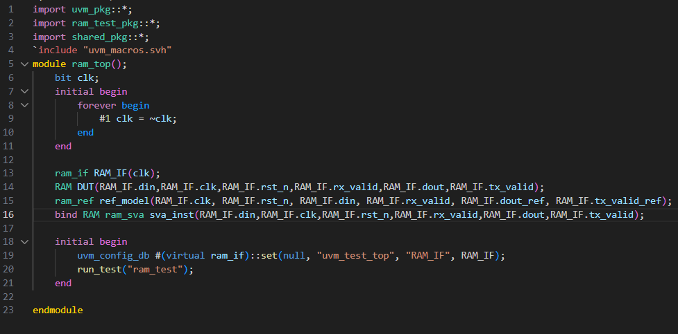

Test: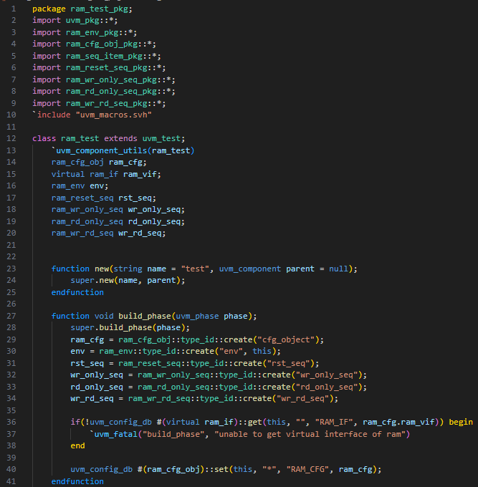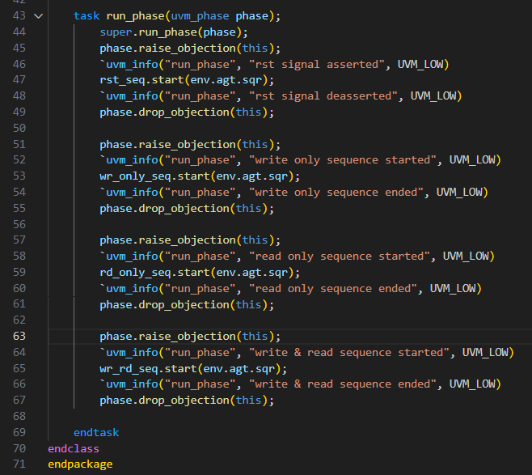

Env: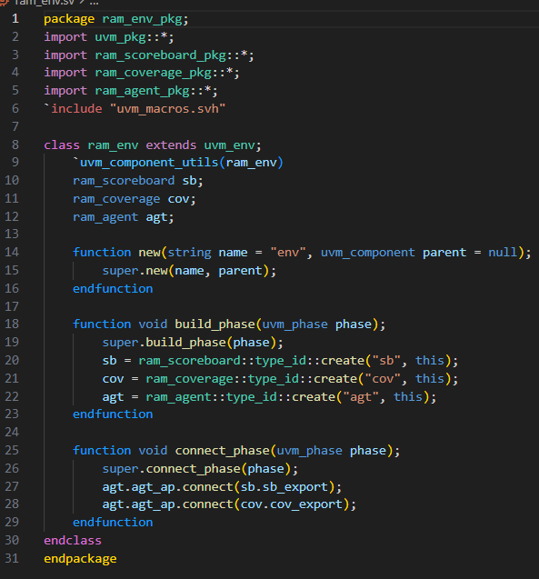

Agent: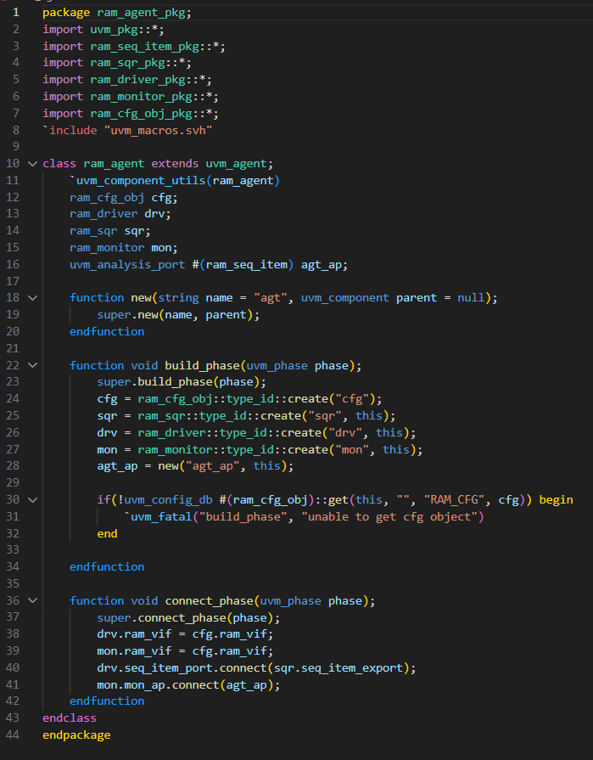

Config Object, Sequence Item and Sequencer:

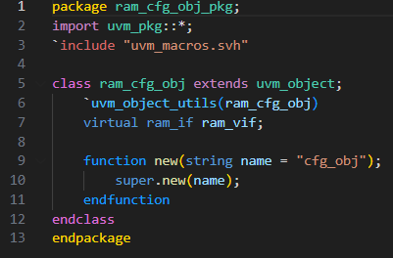

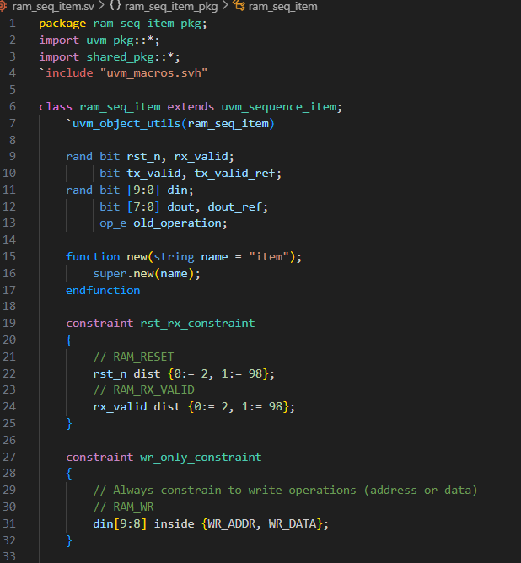

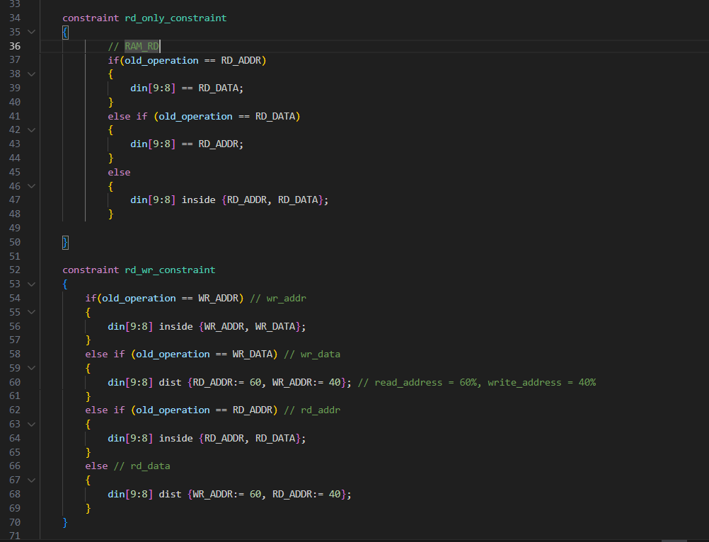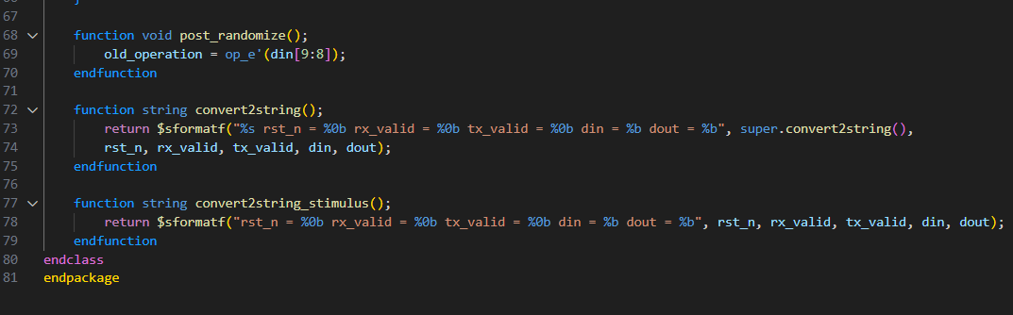

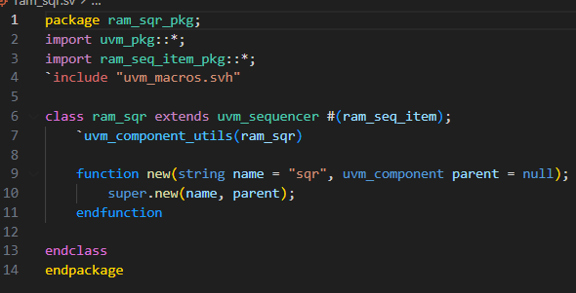

Reset, Write only sequence, Read only sequence and W&R sequence:

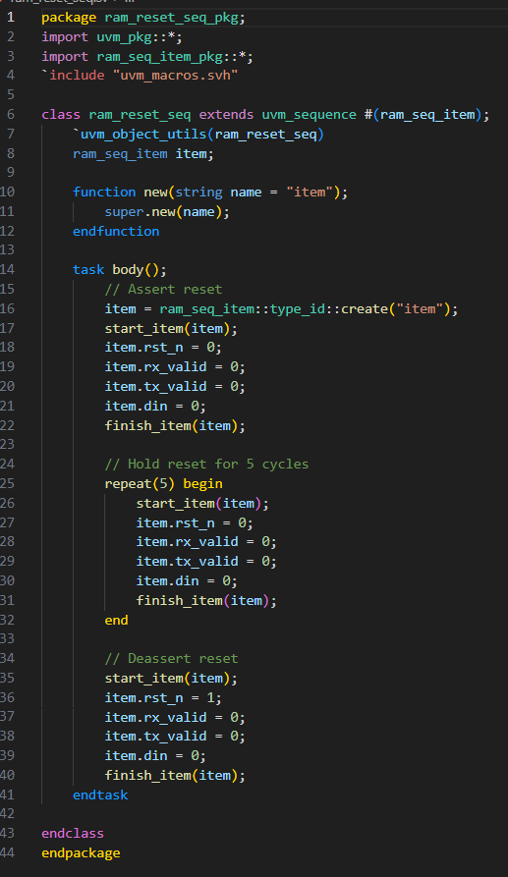

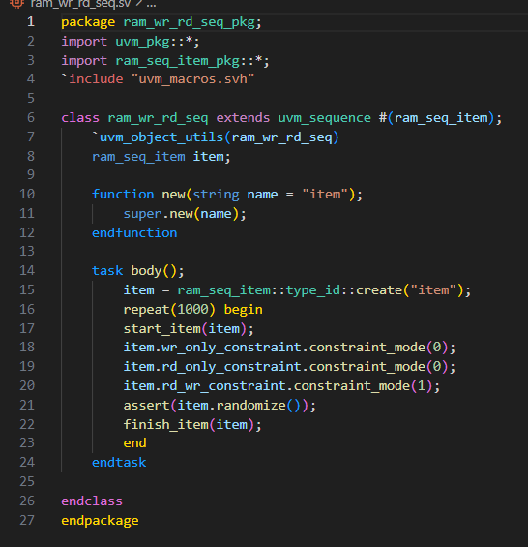

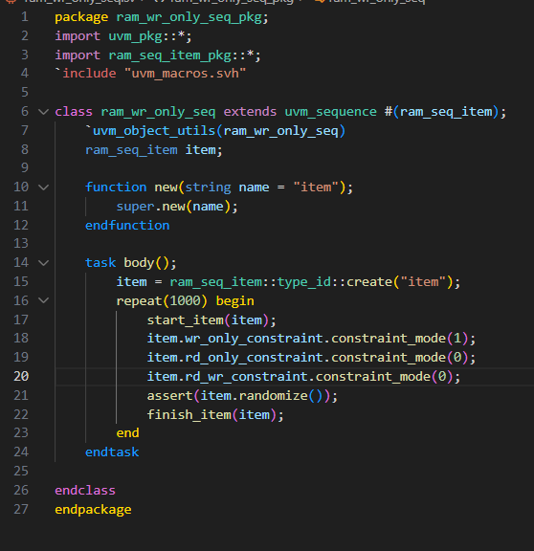

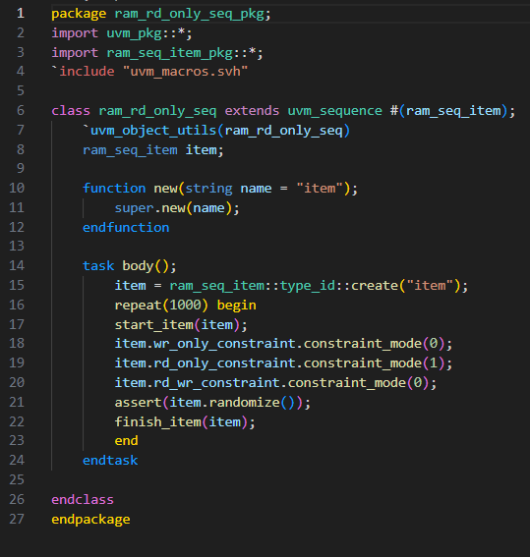

Monitor and Driver: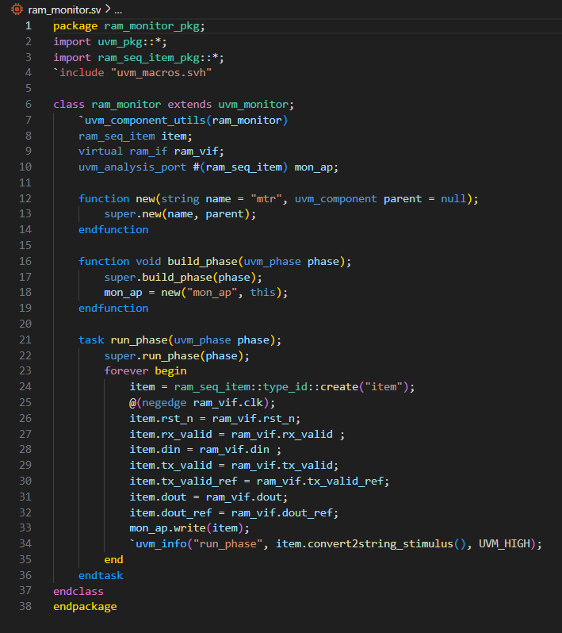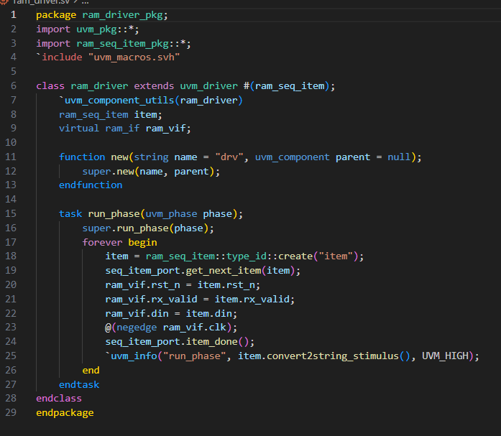

Interface: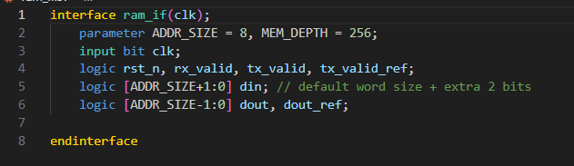

Coverage: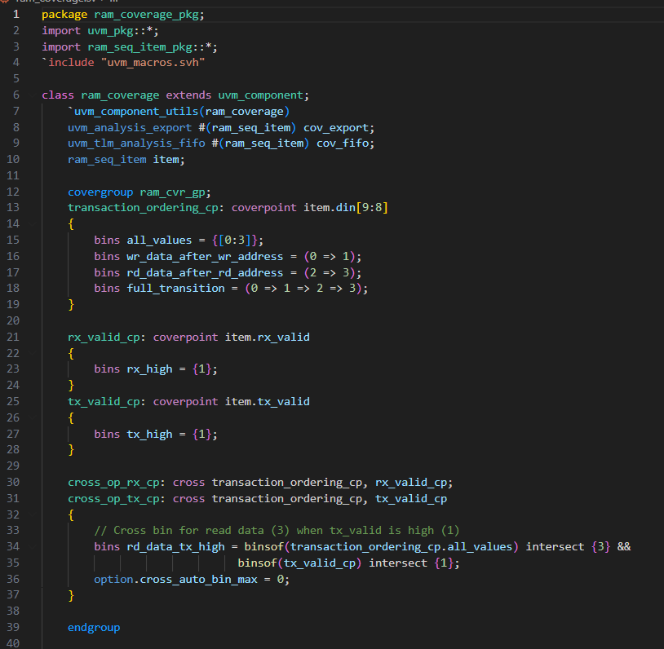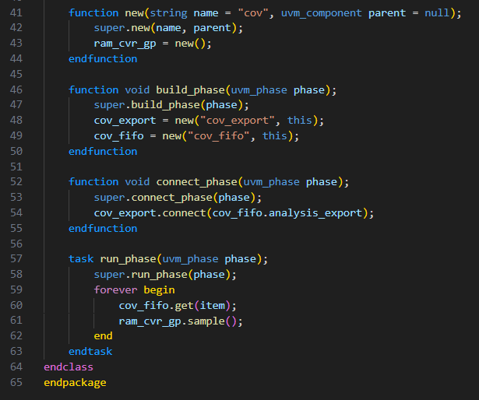

Scoreboard: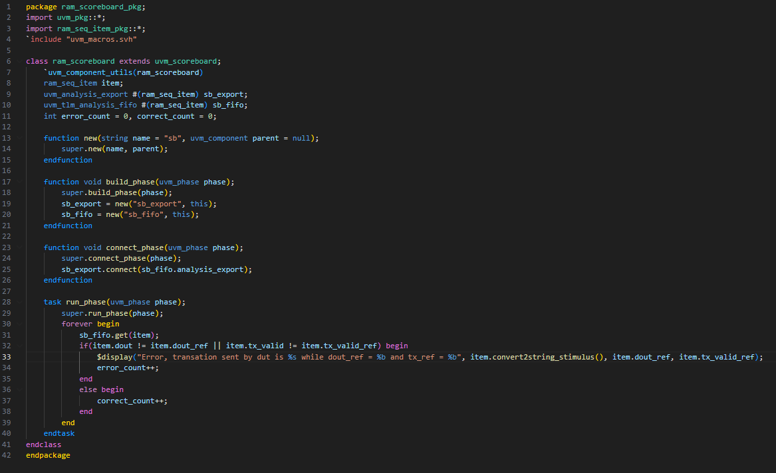

Reference Model: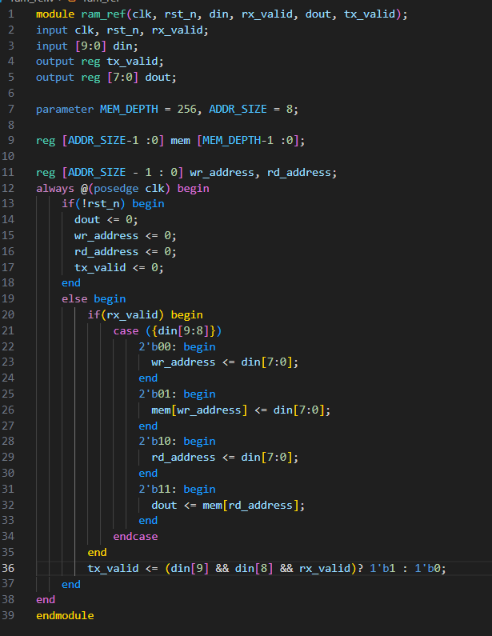

Design: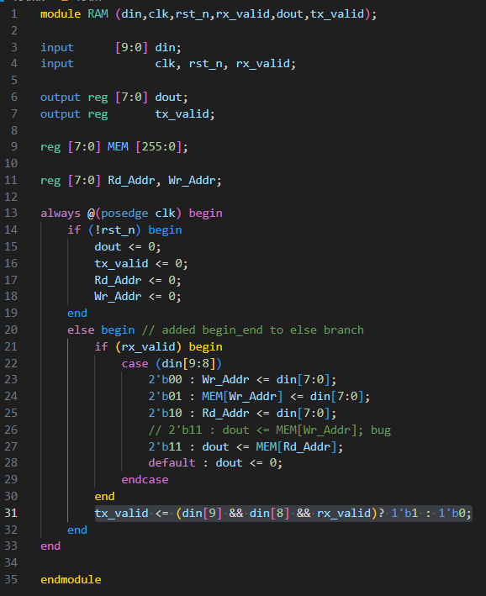

Bugs Found:

1. In READ_DATA case, output would read from Wr_addr.
2. Missing begin end in else branch

Shared_Pkg: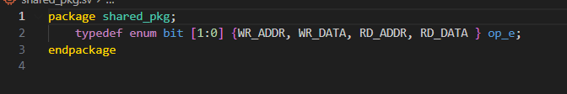

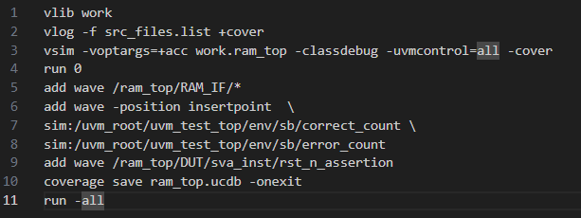Do File:

Assertions: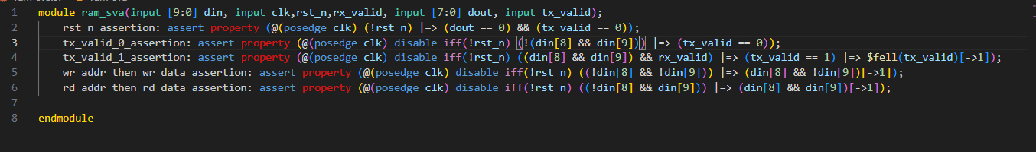

Waveforms:

Reset Sequence: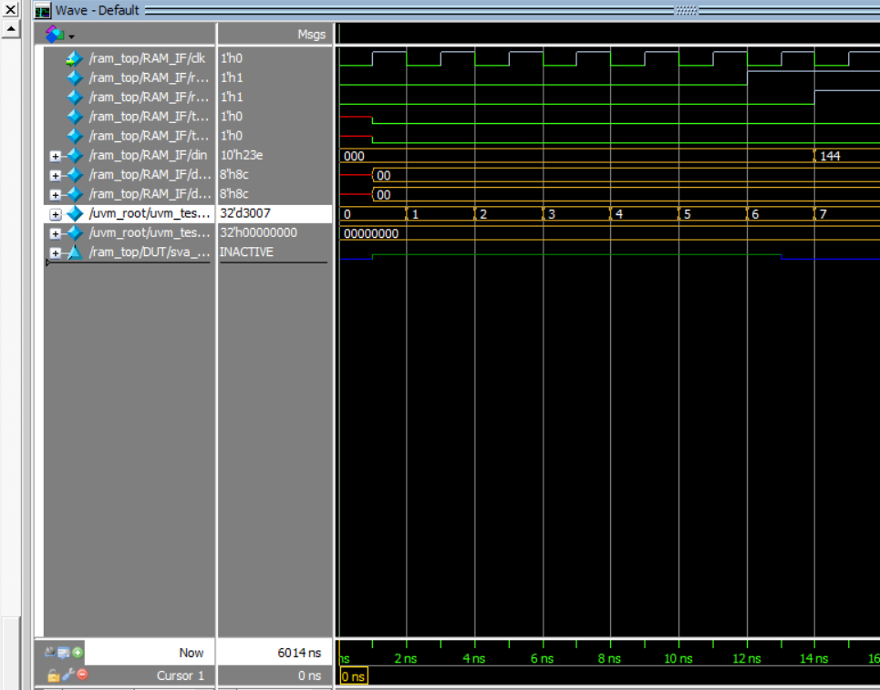

Write-Only Sequence: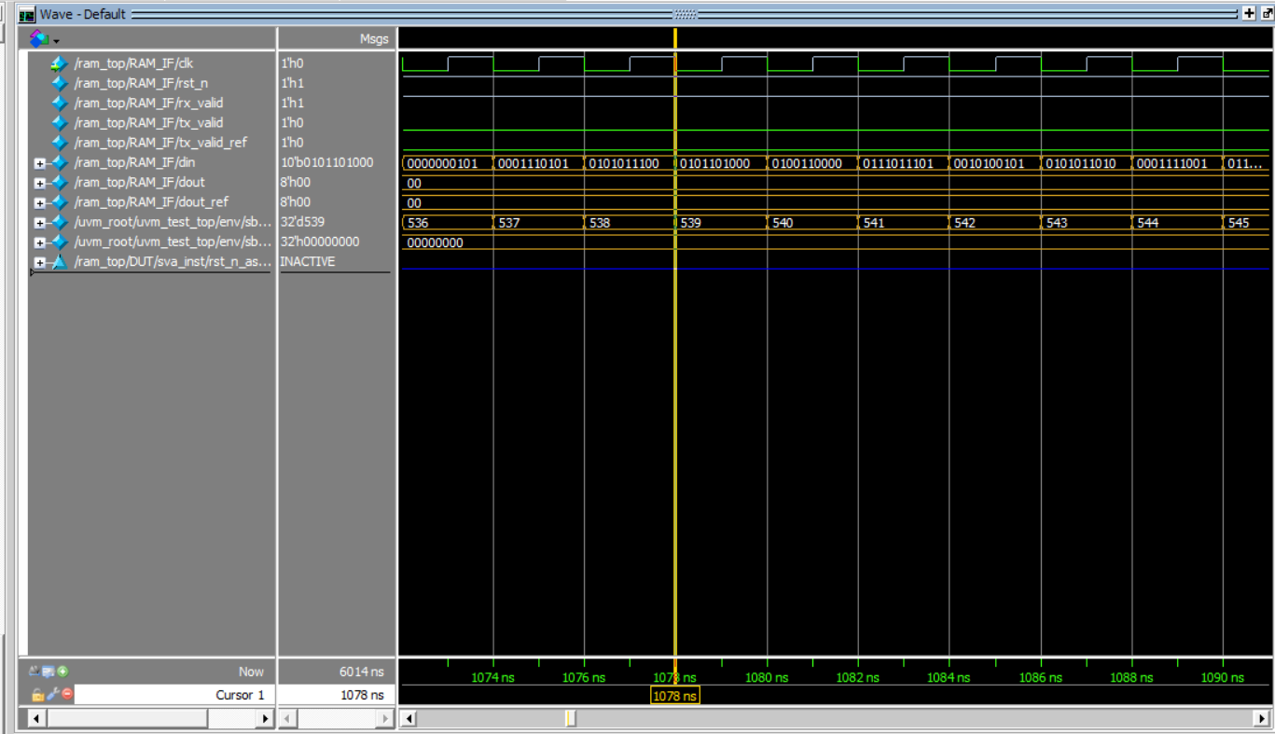

Read-Only Sequence: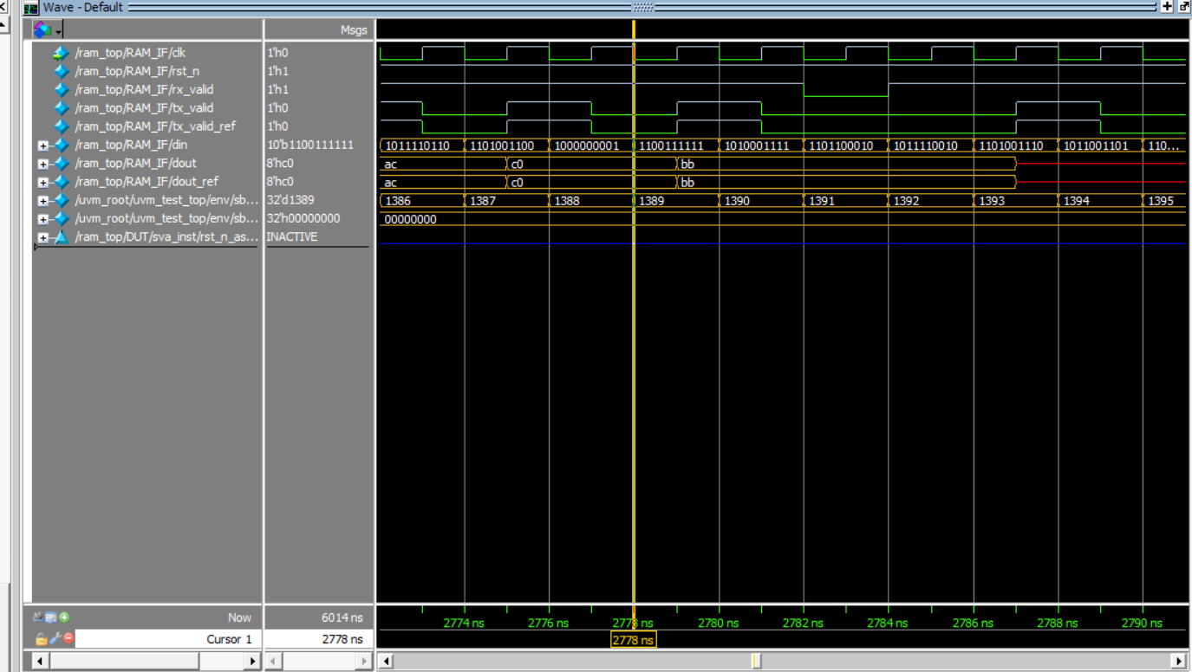

Write & Read Sequence: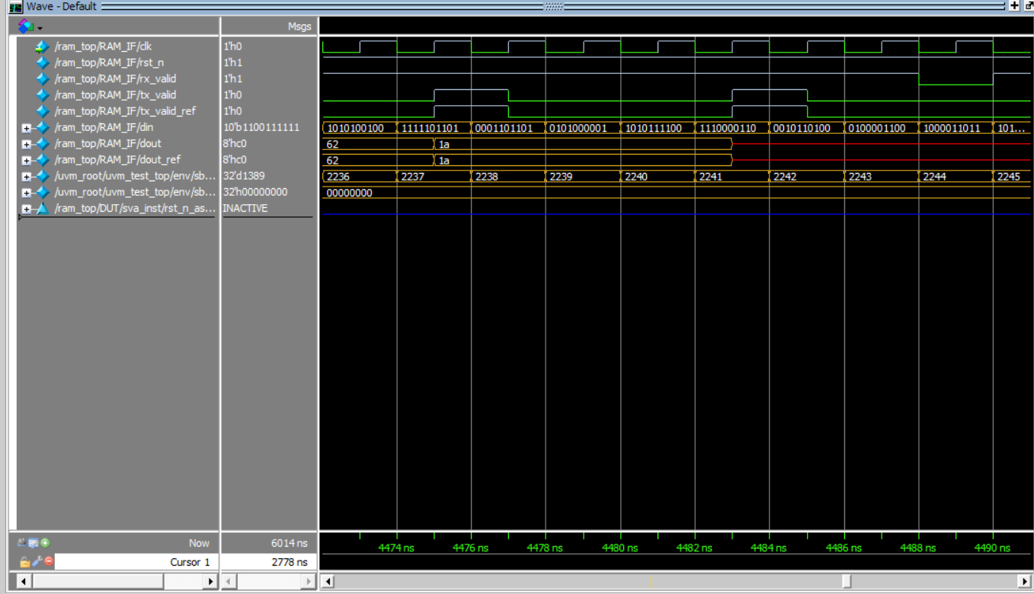

Transcript: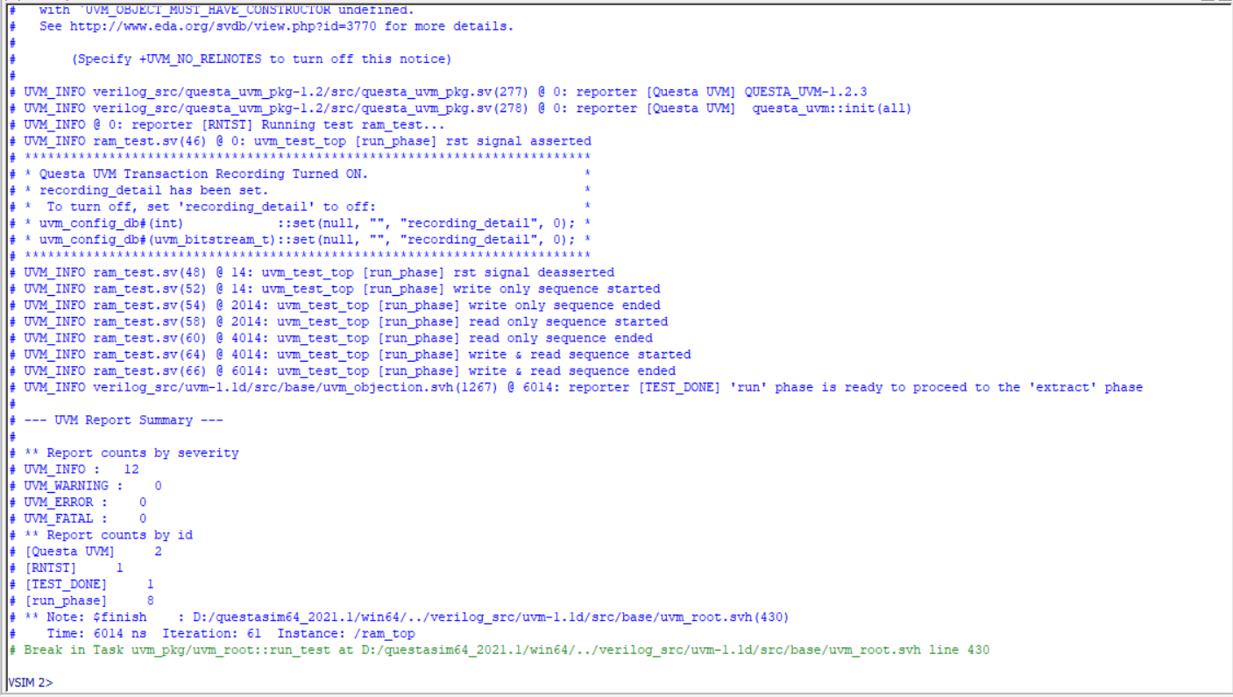

Functional Coverage: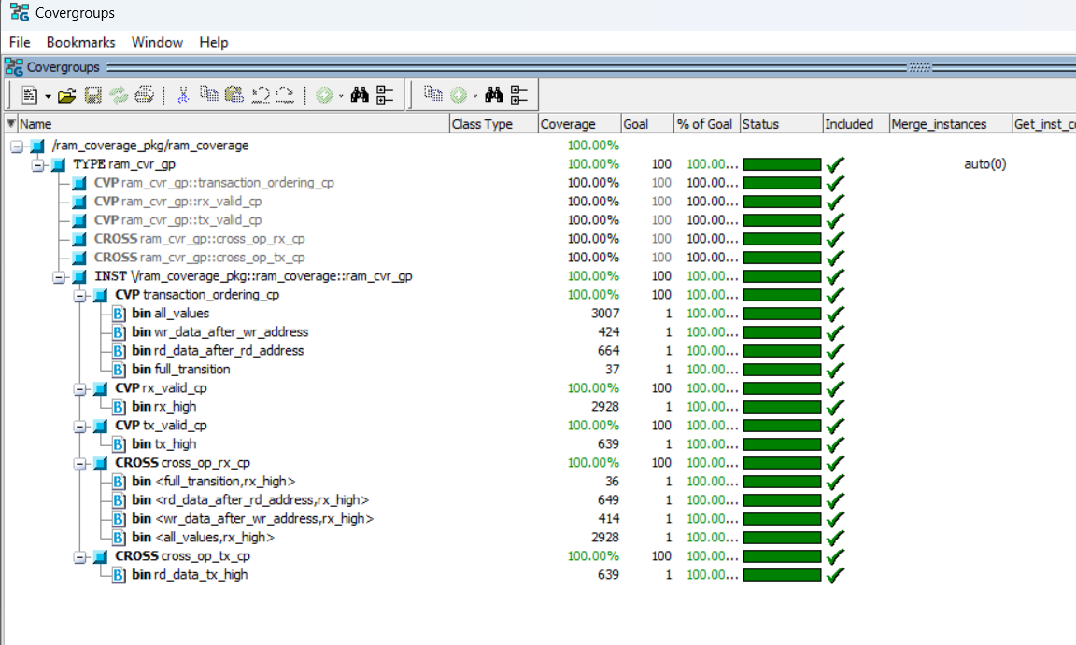

Assertions Coverage: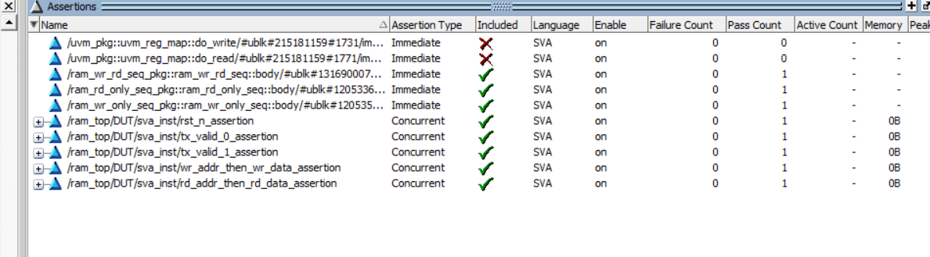

Code Coverage: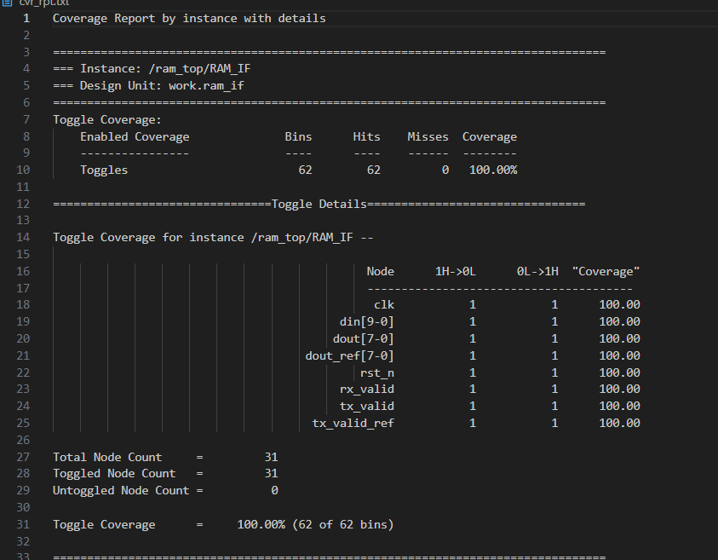

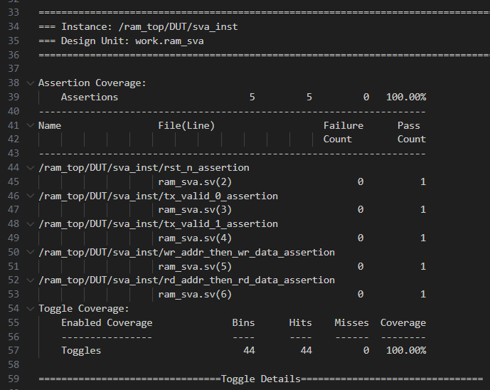

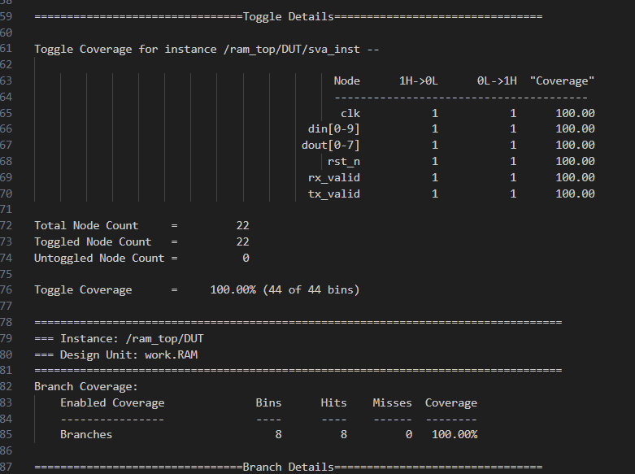

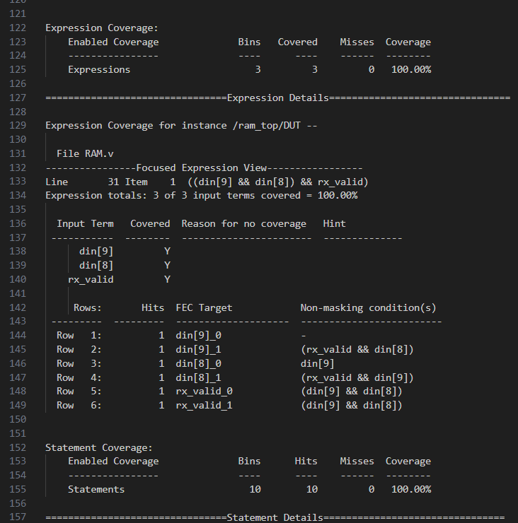

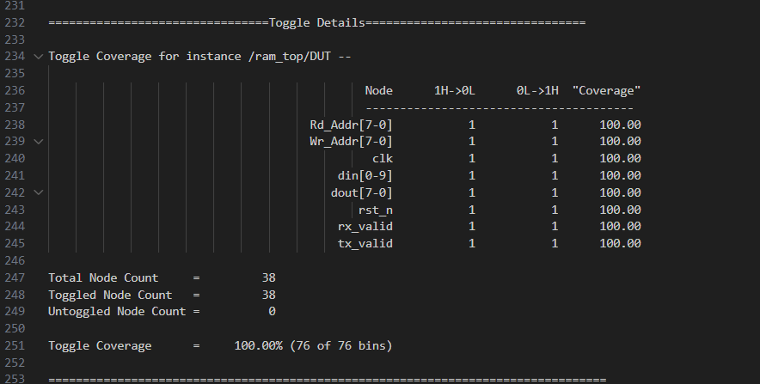

Default branch excluded as all cases are covered.

***3-SPI Wrapper:***

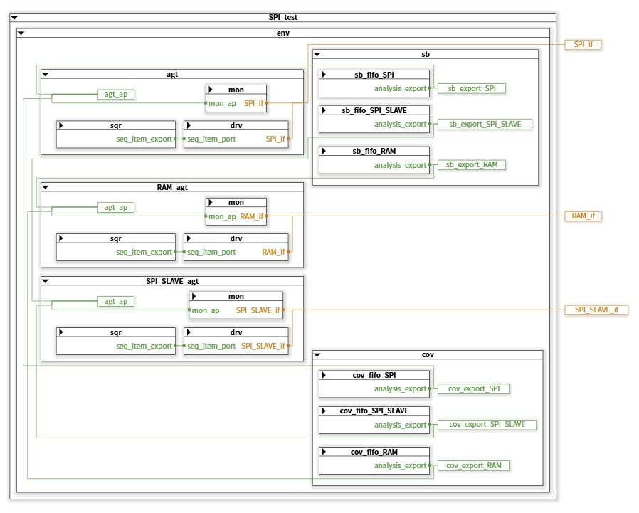 ***3.1. SPI Wrapper UVM architecture:***

The environment includes a scoreboard, coverage, and three agents, one for each component (RAM, SPI Slave, and SPI Wrapper).  
The SPI Wrapper agent is active, and its driver is responsible for driving the data. The SPI Slave and RAM agents are passive; they only monitor the data driven from the SPI Wrapper to the SPI Slave and RAM.

|  |  |
| --- | --- |
| Feature | Assertion |
| An assertion ensures that whenever reset is asserted, the output (MISO) is inactive. | @(posedge clk) !rst_n |=> !MISO; |
| When din[9:8] = 11 and rx_valid is asserted, tx_valid should be high and should eventually fall. | sequence READ_DATA_SEQUENCE;      $fell(SS_n) ##1 (MOSI[->3] ##0 1'b1);  endsequence  property MISO_STABLE_NOT_READ;      @(posedge clk) disable iff (!rst_n)          $fell(SS_n) |=>              (not READ_DATA_SEQUENCE ##1 ($stable(MISO) throughout (!SS_n)) );  endproperty |

***3.2. SPI Wrapper Assertions:***

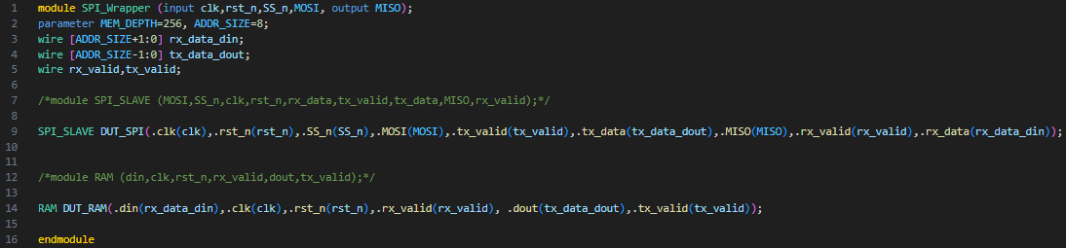***3.3. Codes:***

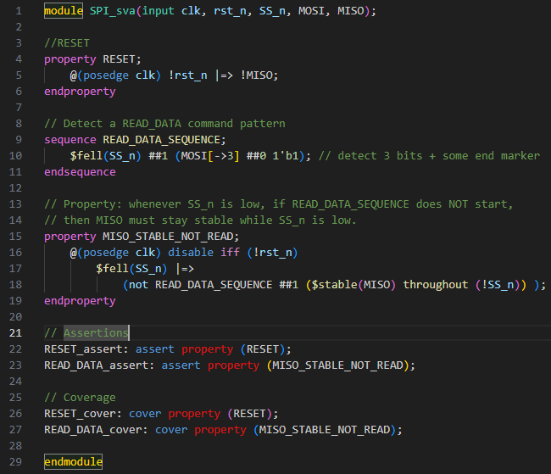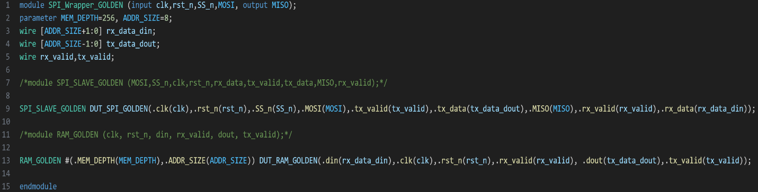

Figure 3: SPI Wrapper sva

Figure 2: SPI Wrapper Golden Model RTL Design

Figure 1: SPI Wrapper RTL Design

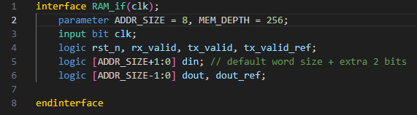

Figure 4: RAM if

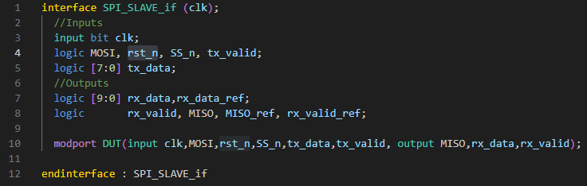

Figure 5: SPI Slave if

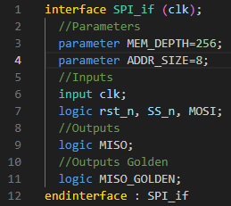

Figure 6: SPI Wrapper if

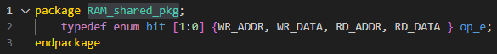

Figure 7: RAM Package

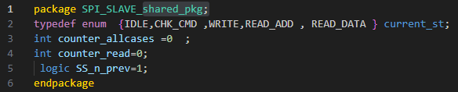

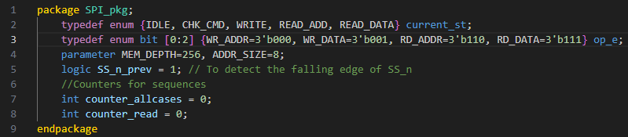

Figure 8: SPI Slave Package

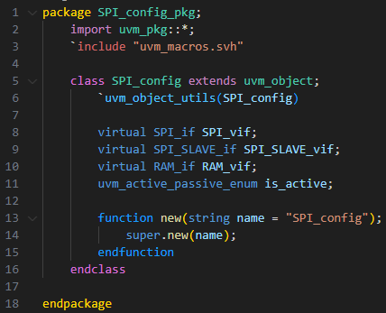

Figure 9: SPI Wrapper Package

Figure 10: Config

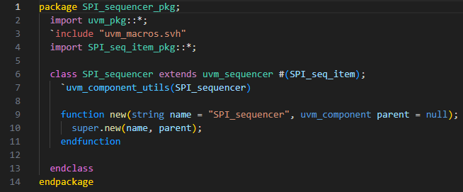

Figure 11: SPI Wrapper Sequencer

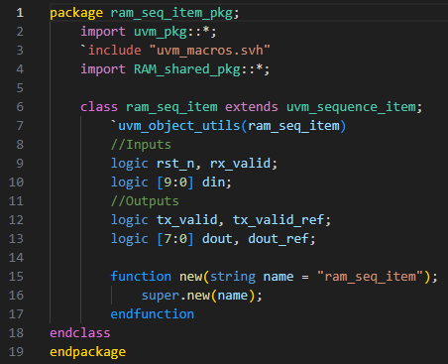

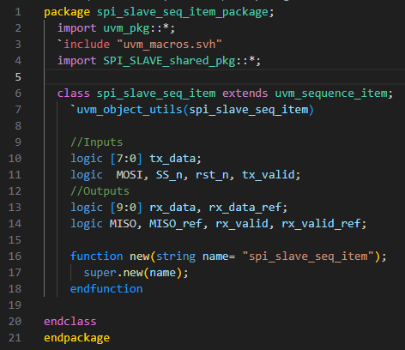

Figure 12: RAM Sequence Item

Figure 13: SPI Slave Sequence Item

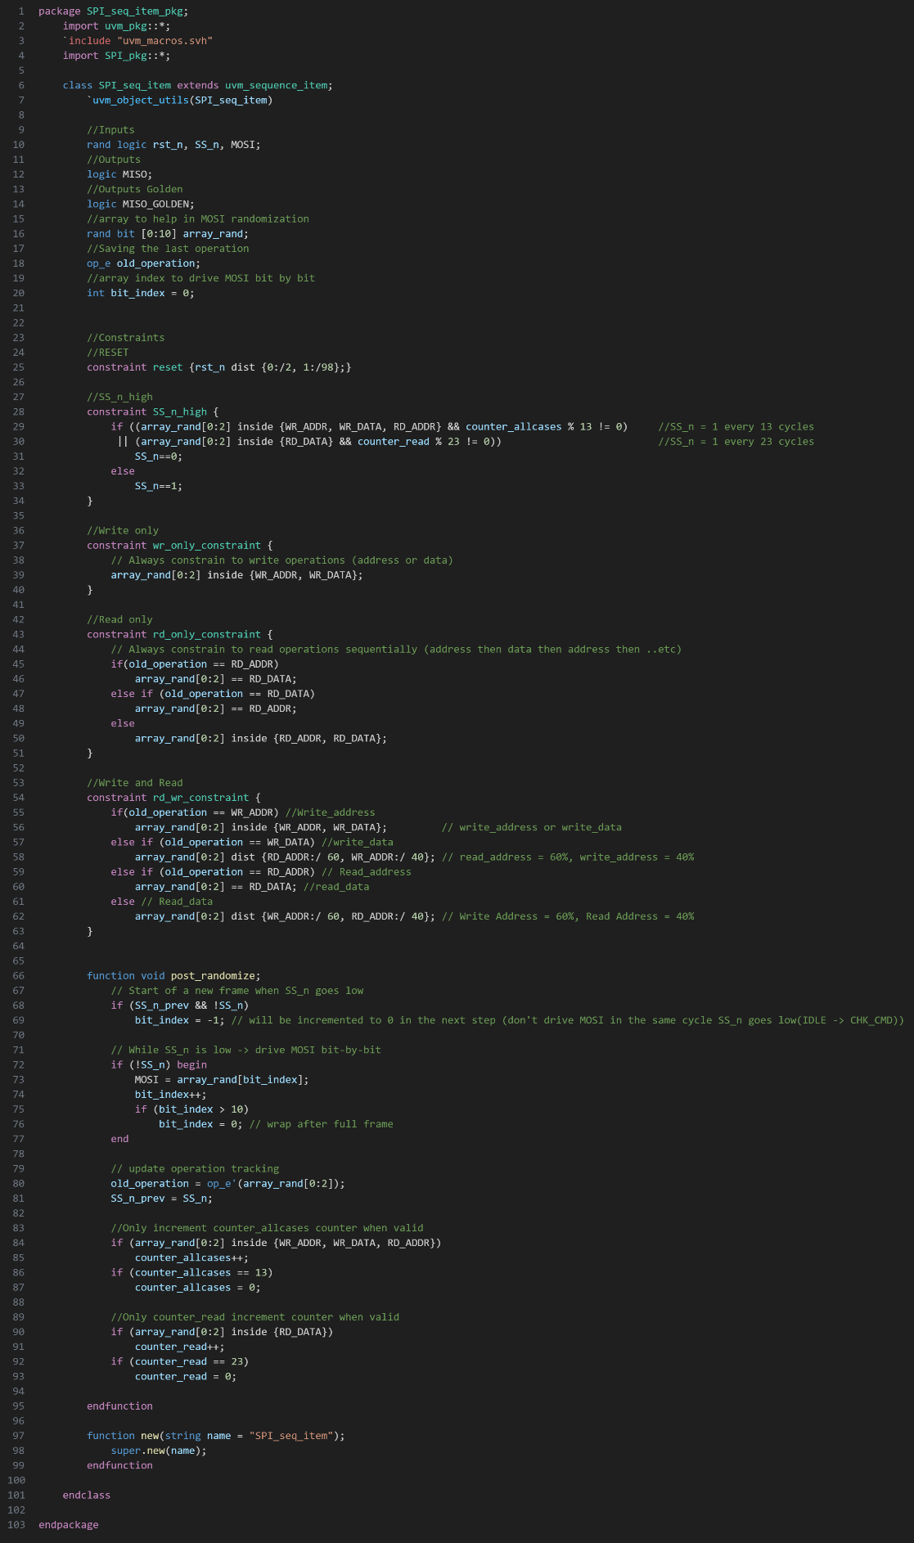

Figure 14: SPI Wrapper Sequence Item

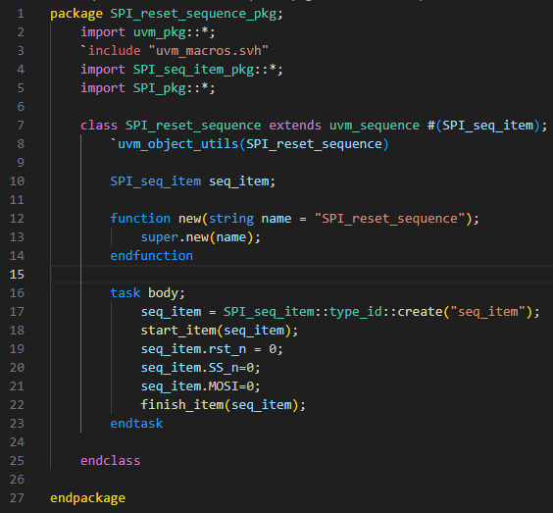

Figure 15: Reset Sequence

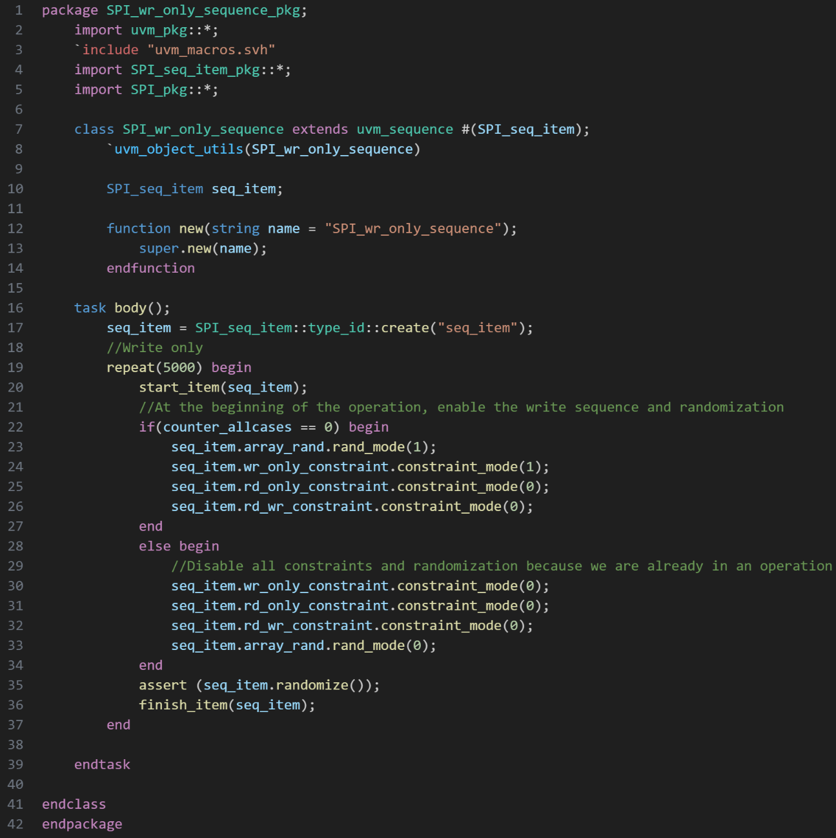

Figure 16: Write only Sequence

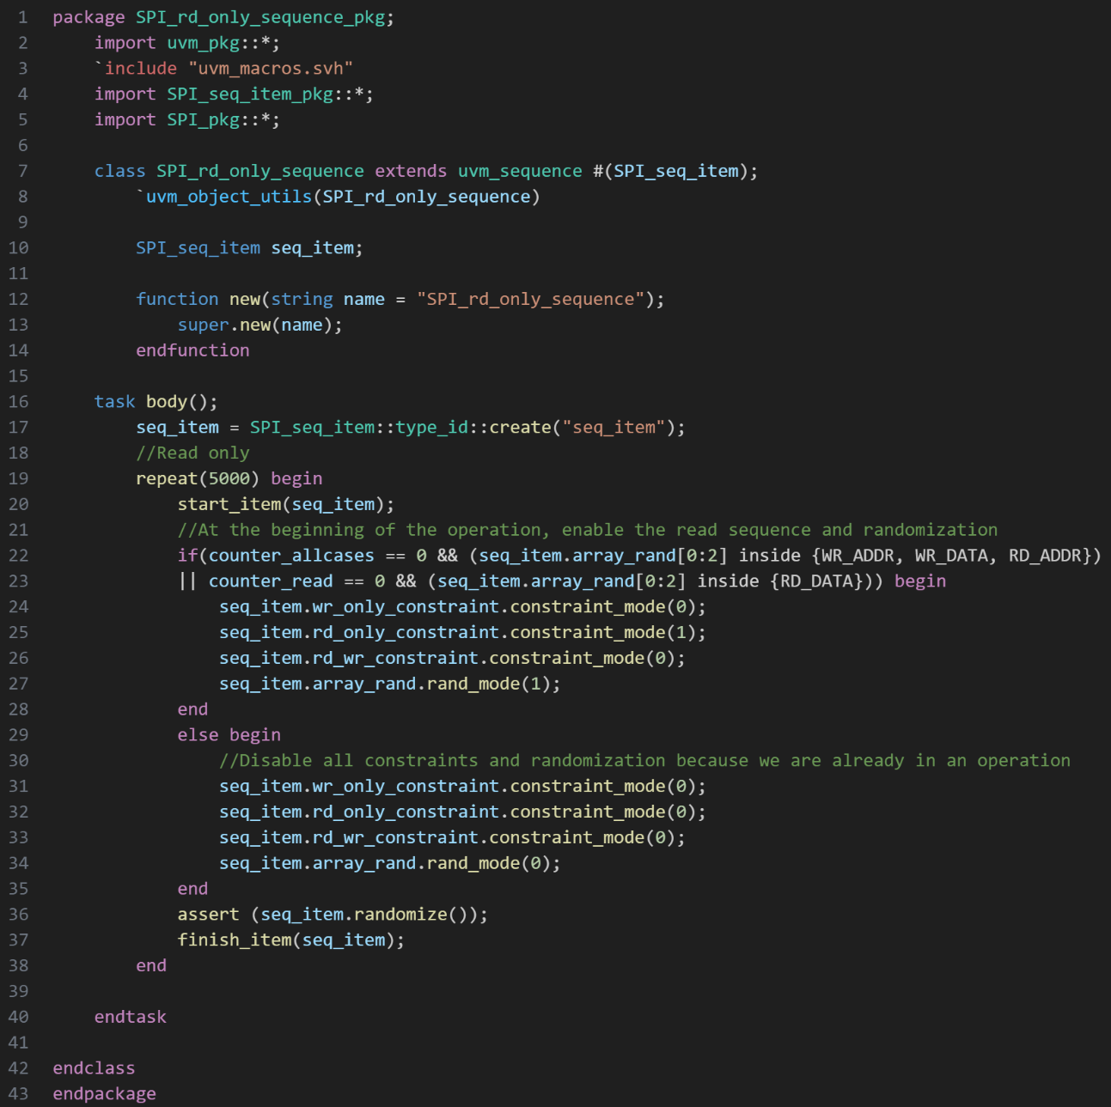

Figure 17: Read only Sequence

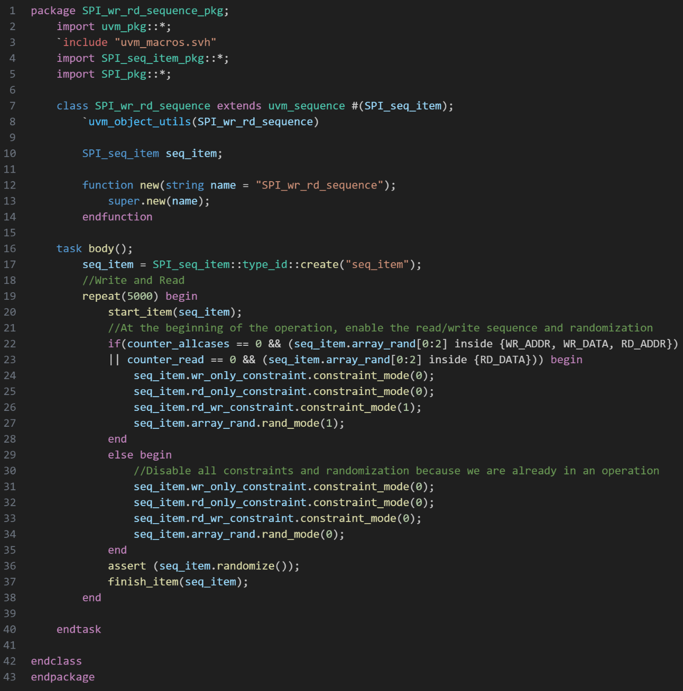

Figure 18: Write/Read Sequence

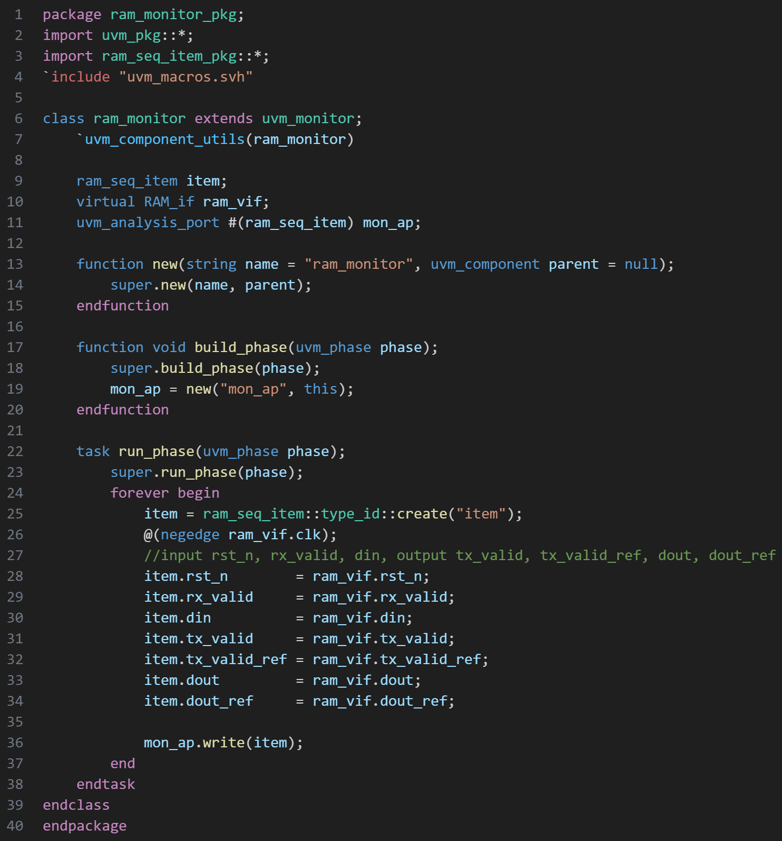

Figure 19: RAM Monitor

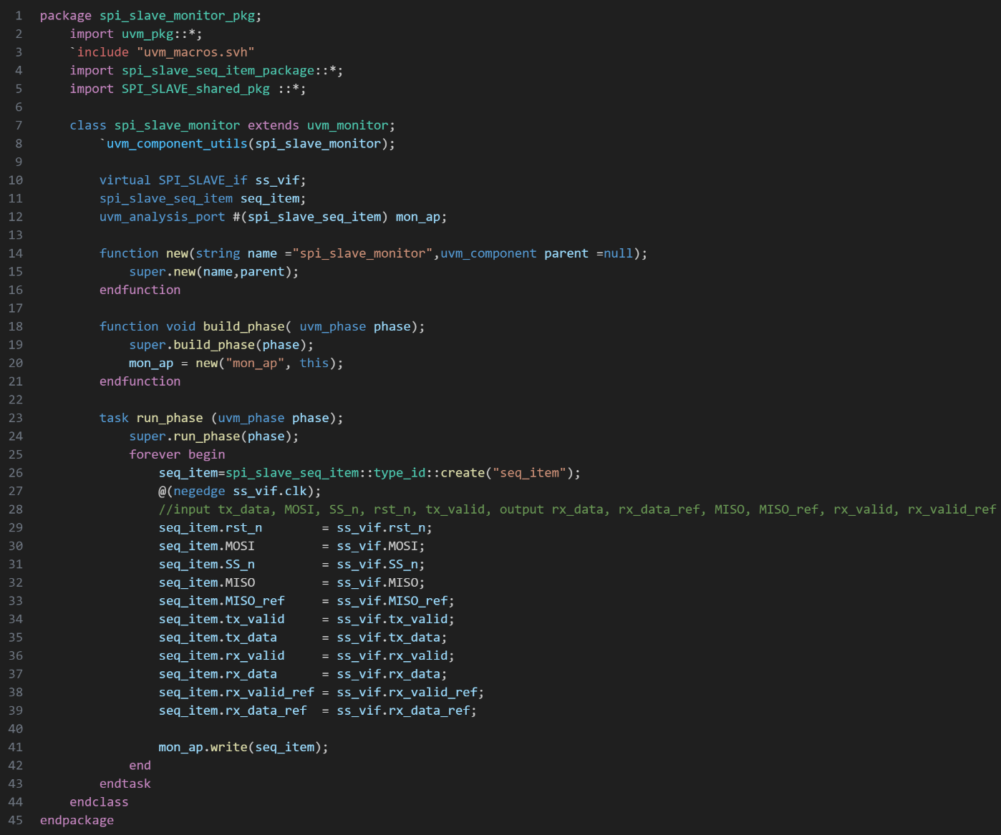

Figure 20: SPI Slave Monitor

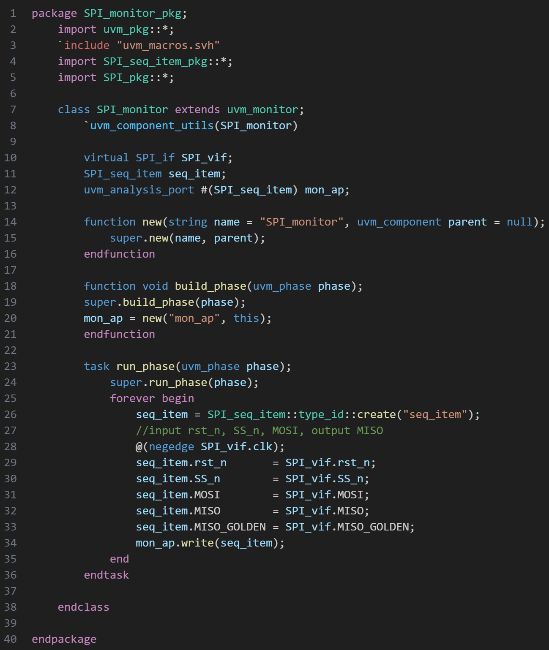

Figure 21: SPI Wrapper Monitor

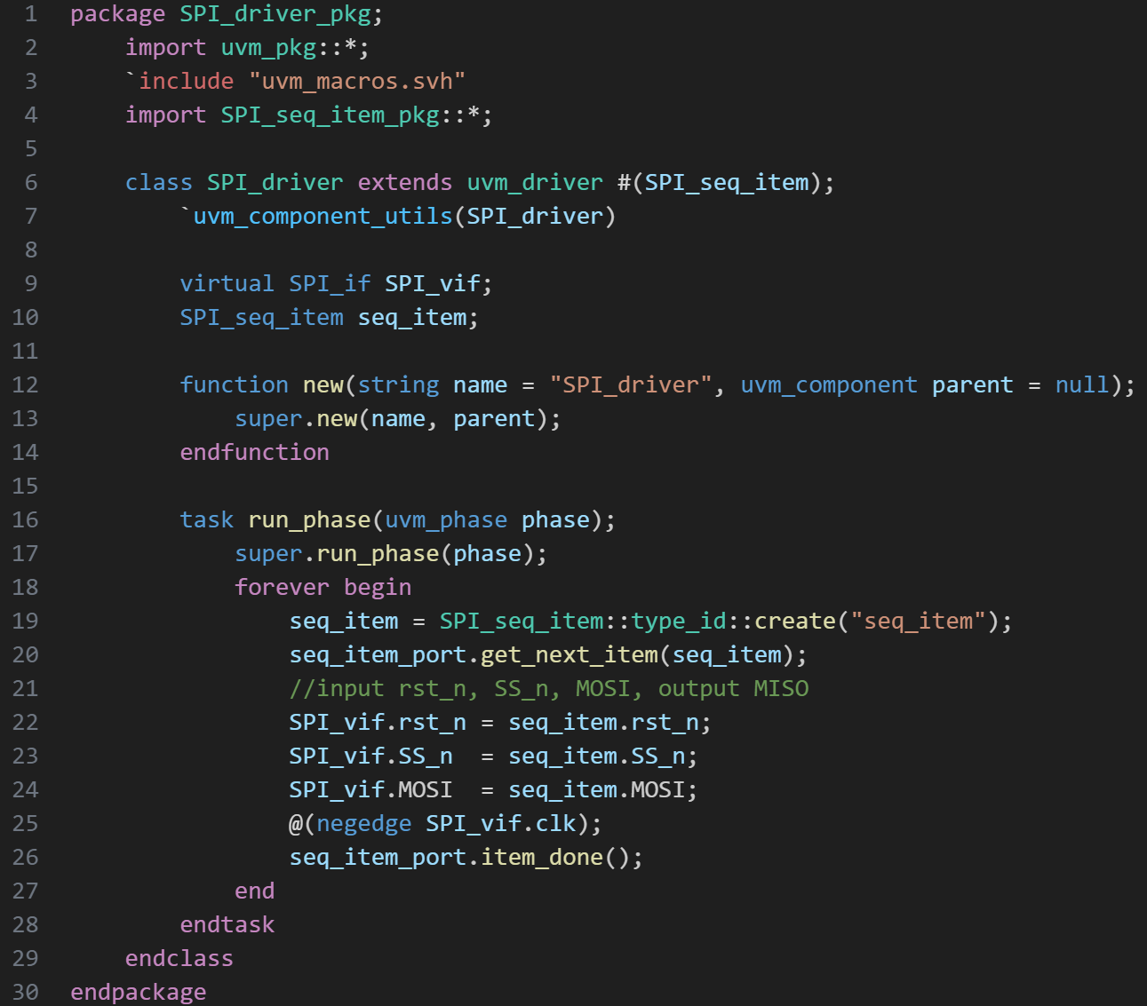

Figure 22: SPI Wrapper Driver

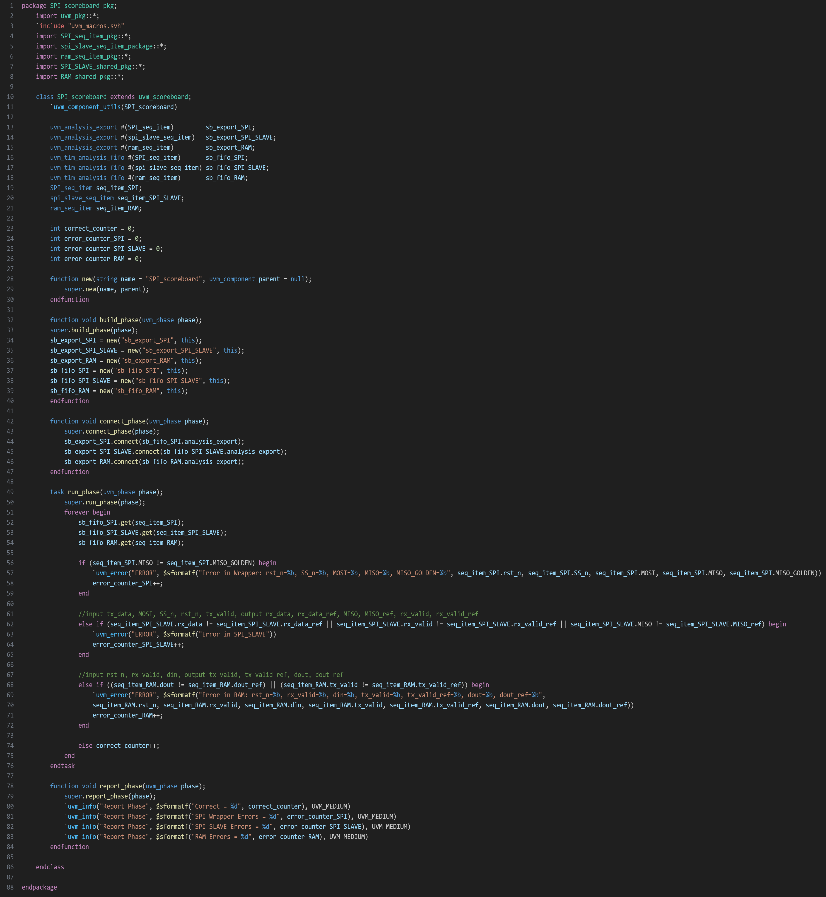

Figure 23: Scoreboard

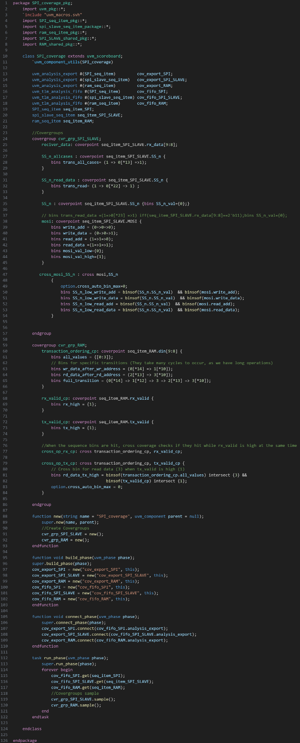

Figure 24: Coverage

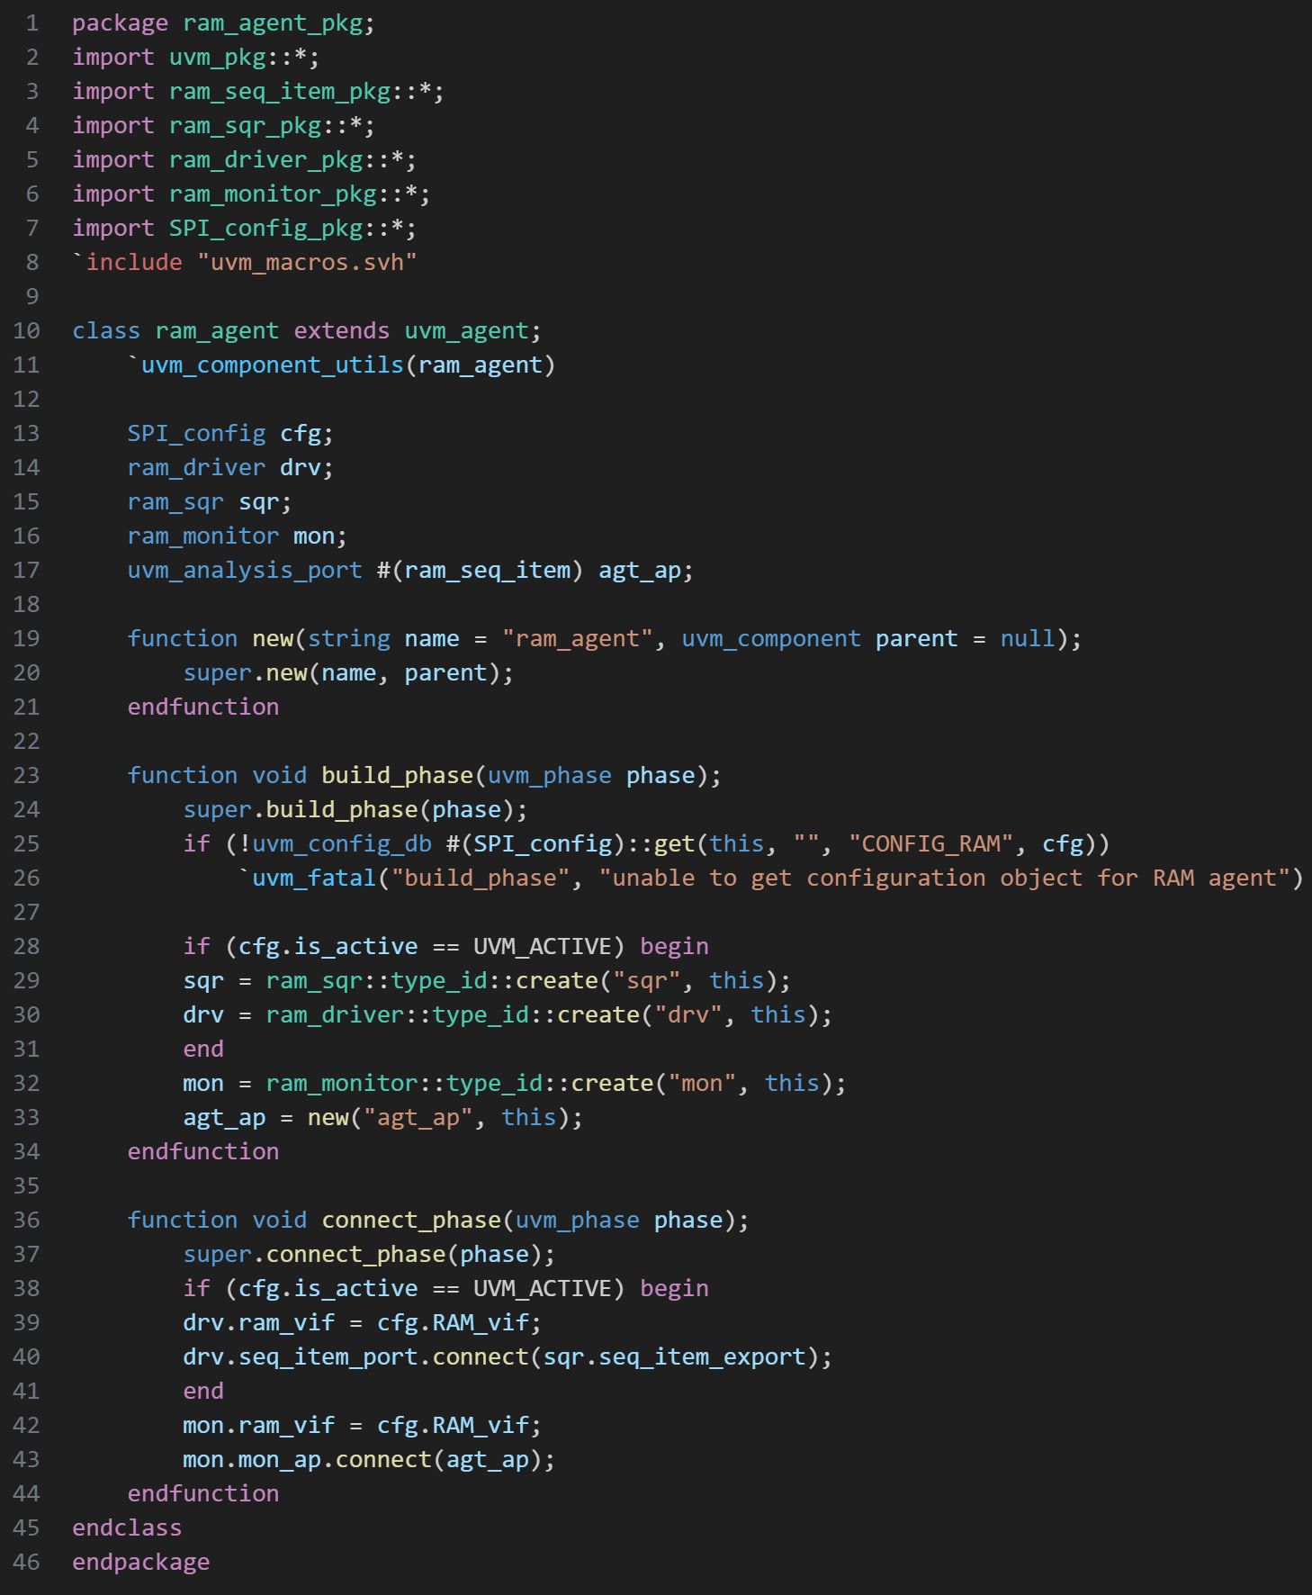

Figure 25: RAM Agent

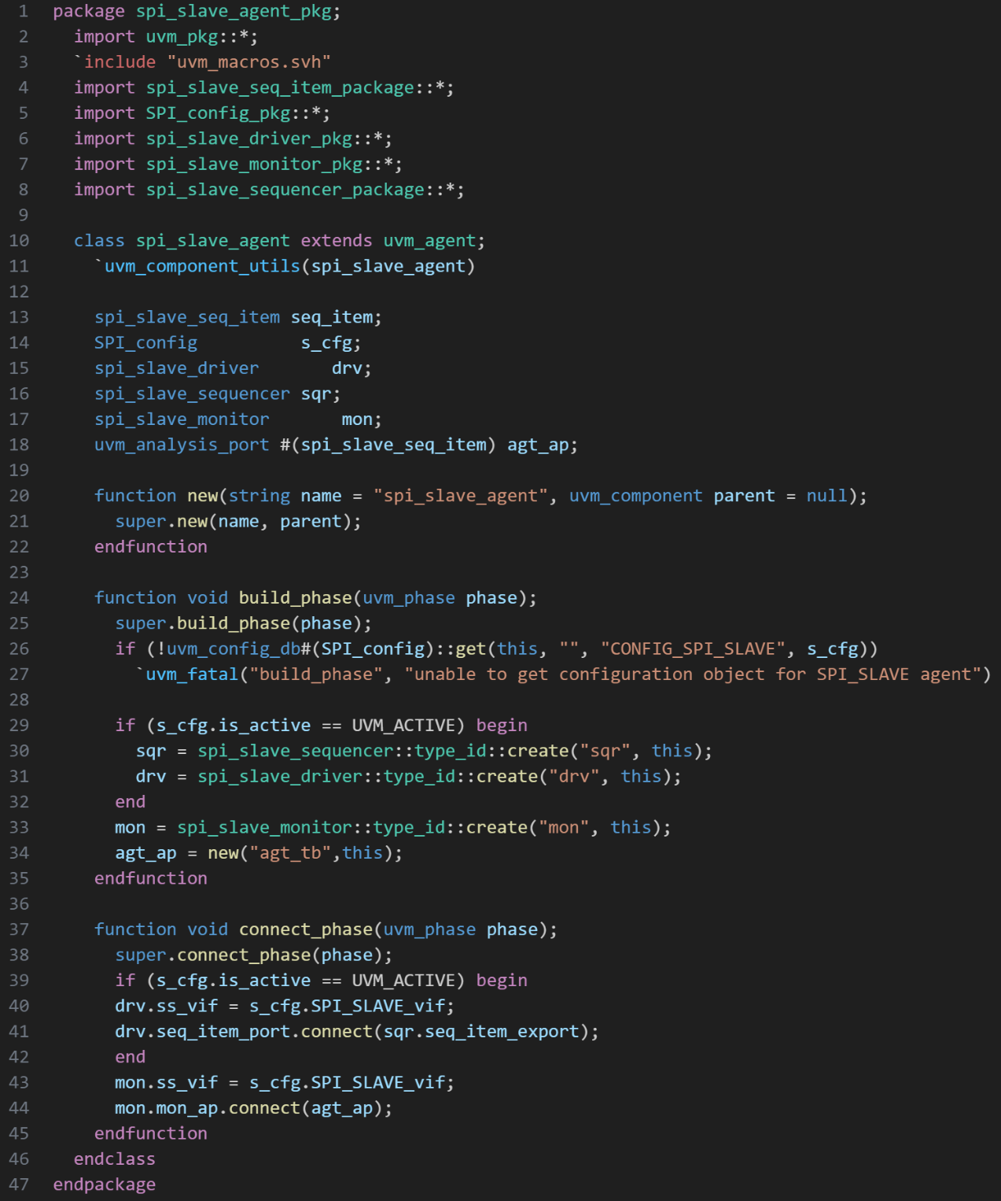

Figure 26: SPI Slave Agent

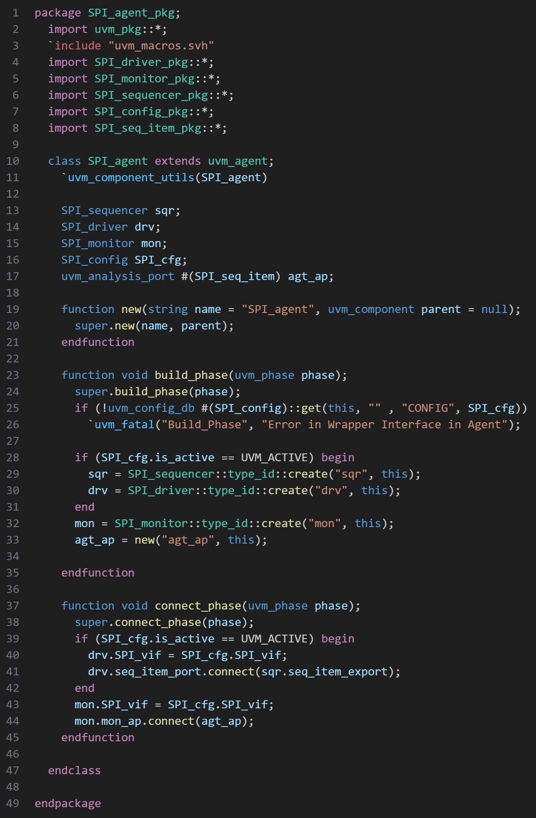

Figure 27: SPI Wrapper Agent

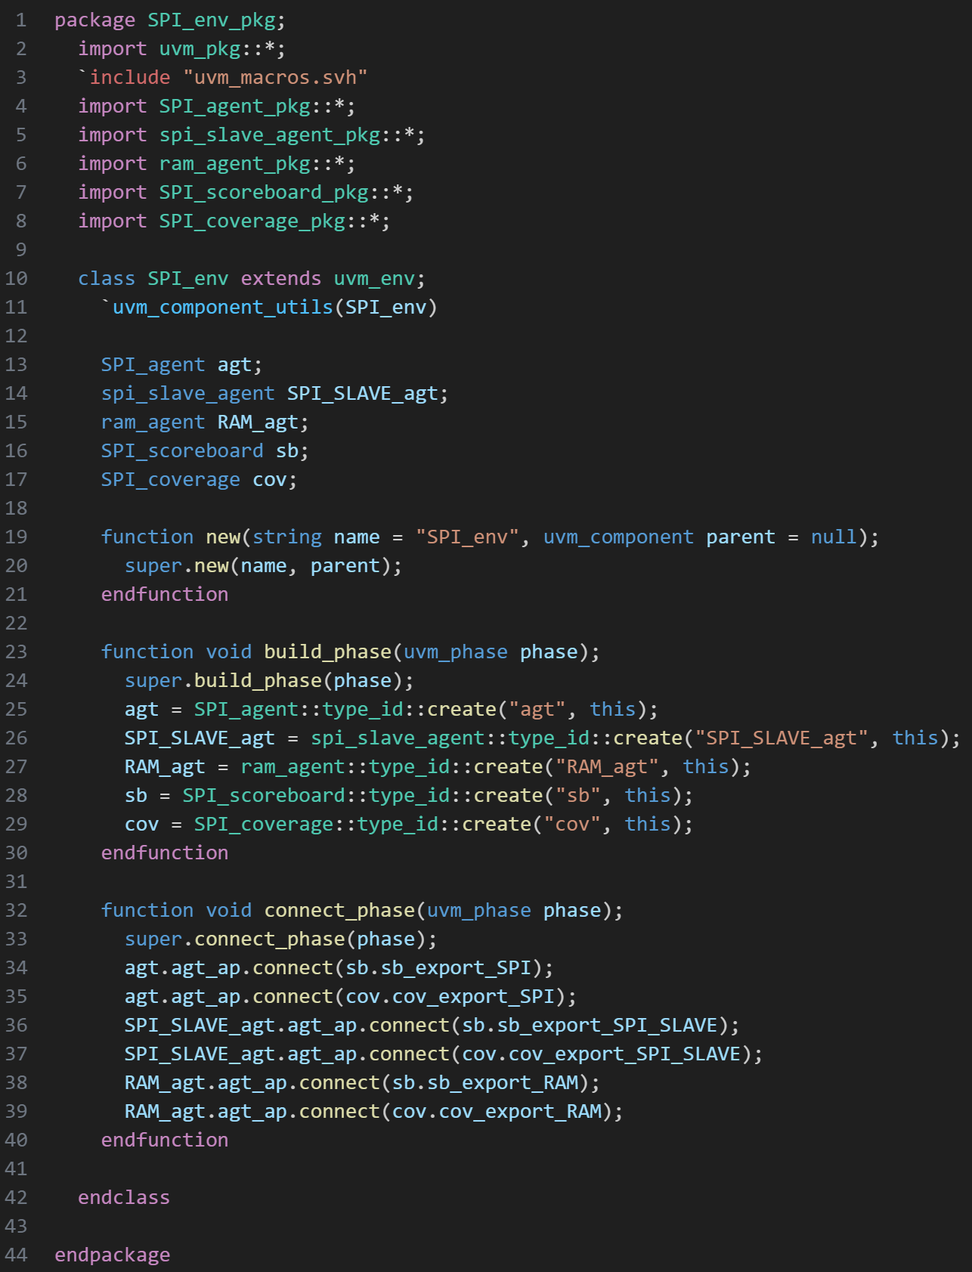

Figure 28: Env

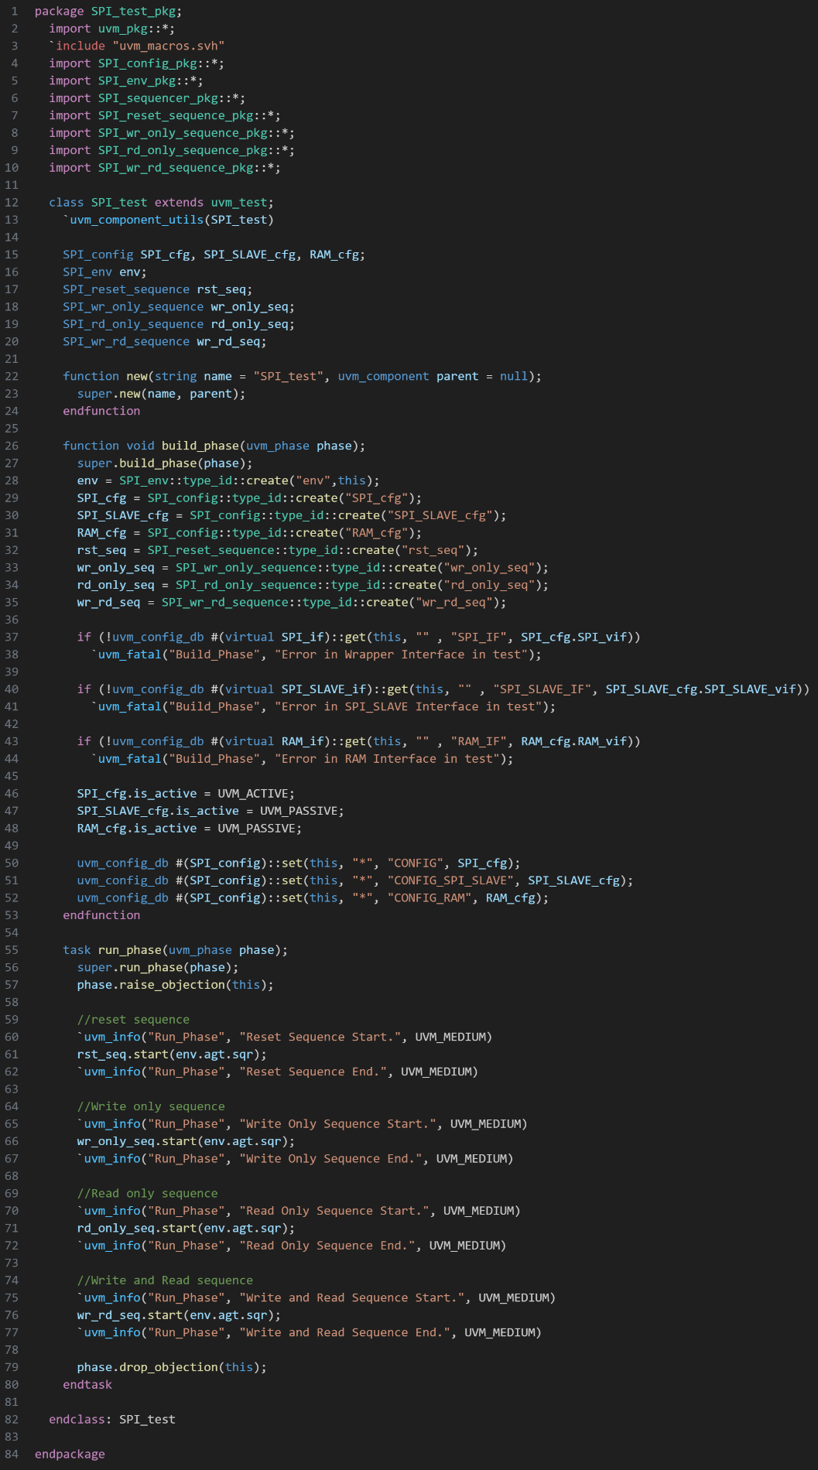

Figure 29: Test

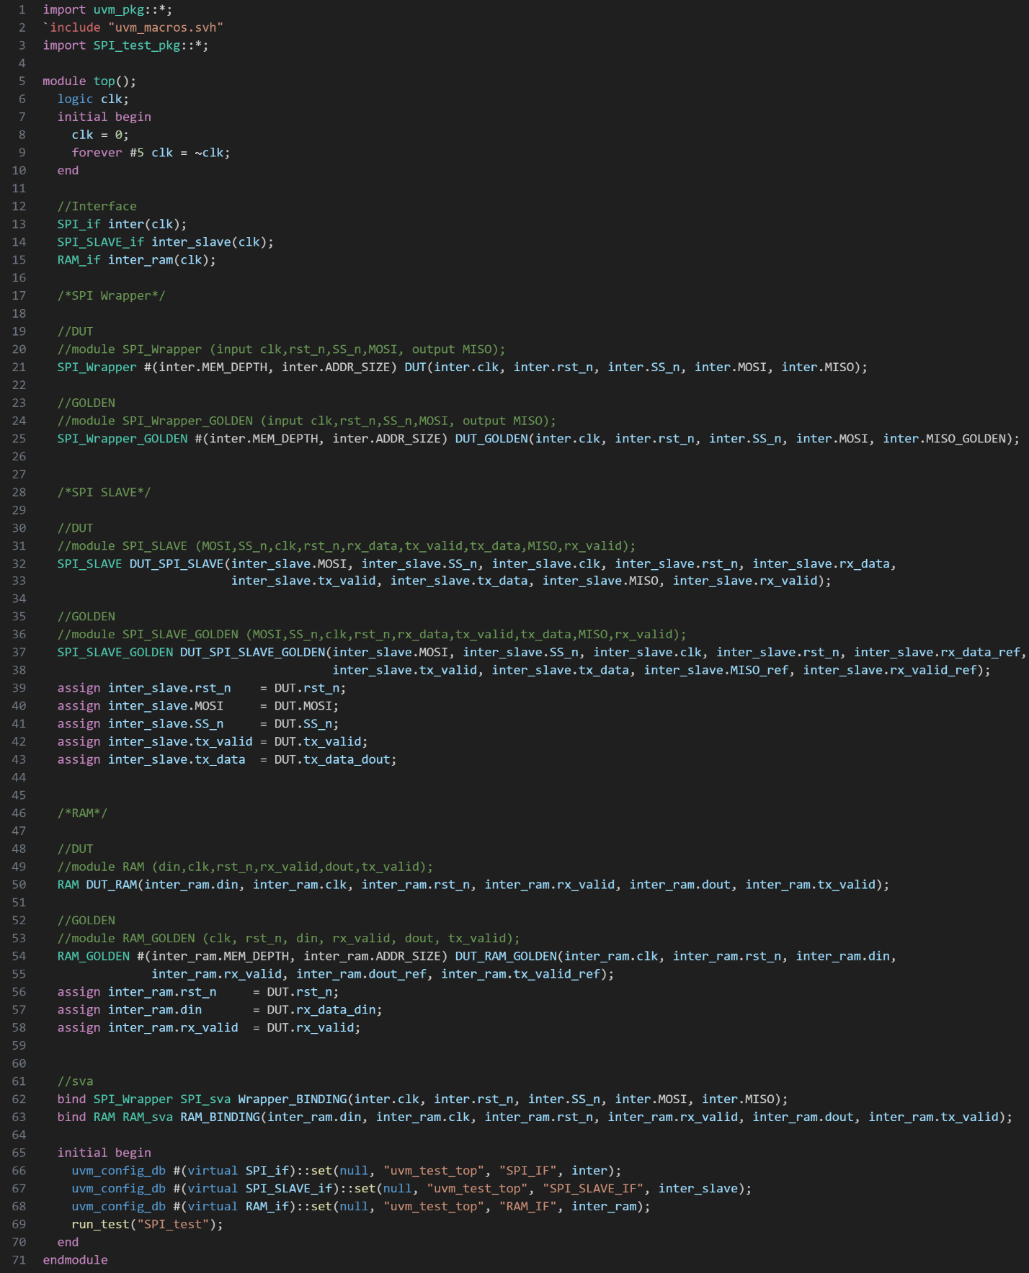

Figure 30: Top

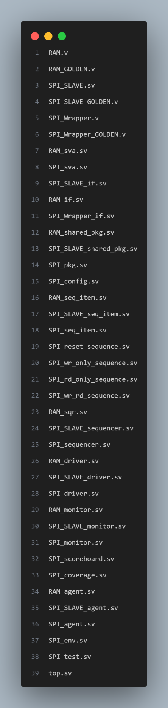

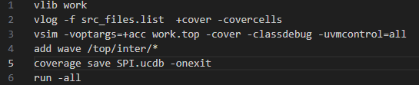

Figure 31: Do File

Figure 32: src File

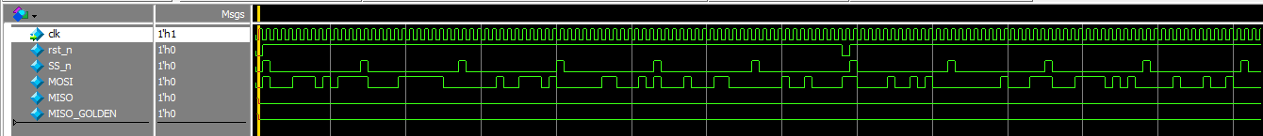***3.4. Wave:***

Figure 33: Reset Sequence Wave

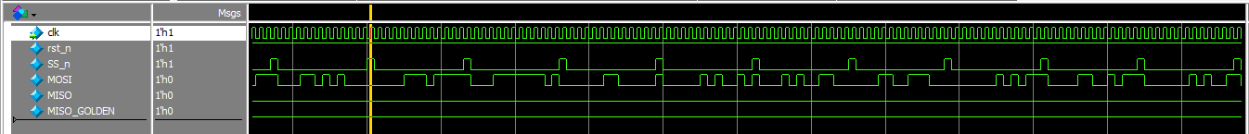

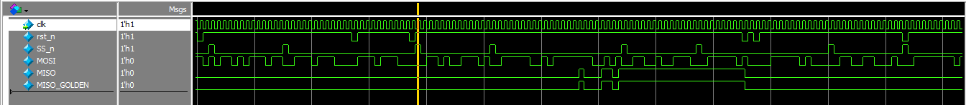

Figure 34: Write only Sequence Wave

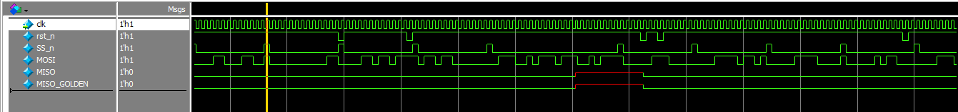

Figure 36: Write/Read Sequence Wave

Figure 35: Read only Sequence Wave

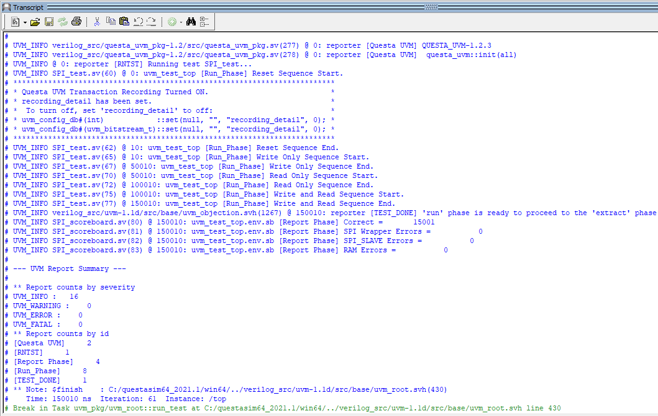

Figure 37: Transcript

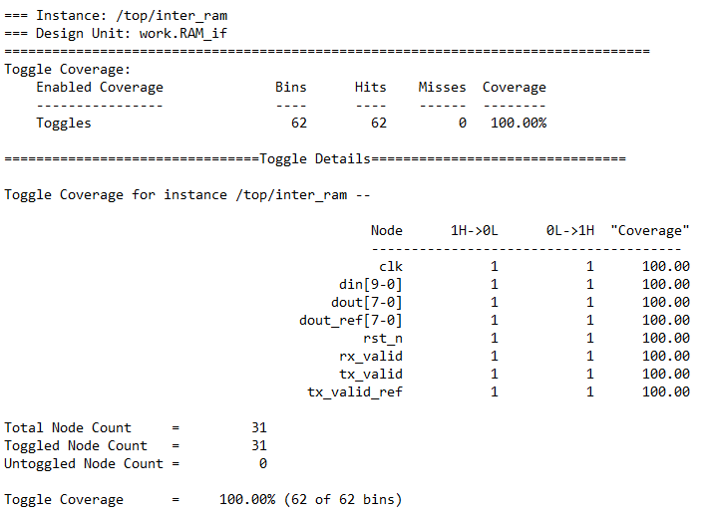***3.5. Coverage:***

Figure 38: Ram Toggle Coverage

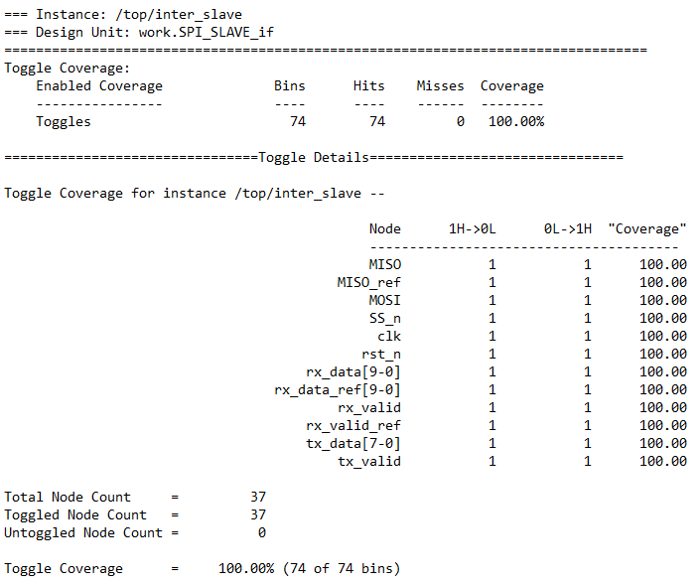

Figure 39: SPI Slave Toggle Coverage

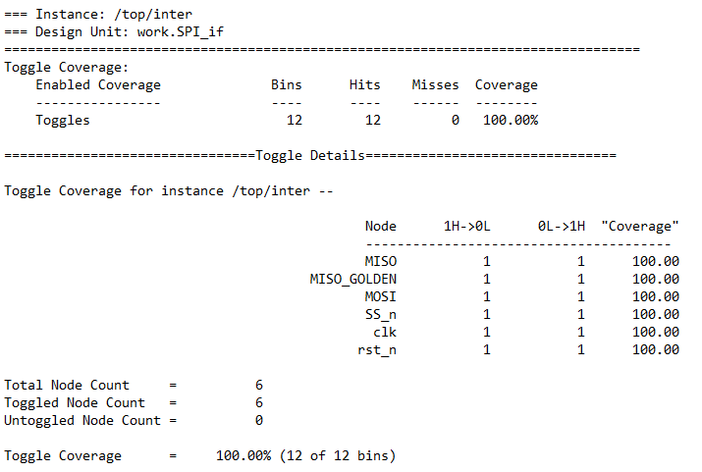

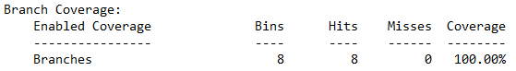

Figure 41: Ram Branch Coverage

Figure 40: SPI Wrapper Toggle Coverage

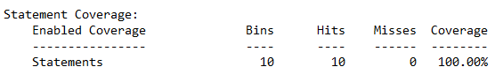

Figure 42: Ram Statement Coverage

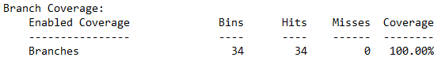

Figure 43: SPI Slave Branch Coverage

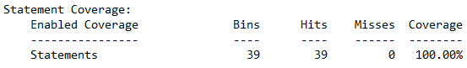

Figure 44: SPI Slave Statement Coverage

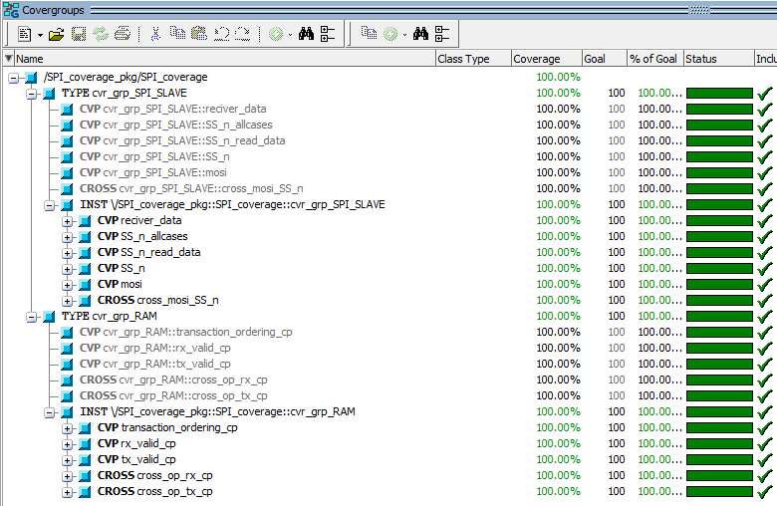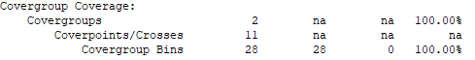

Figure 45: Functional Coverage

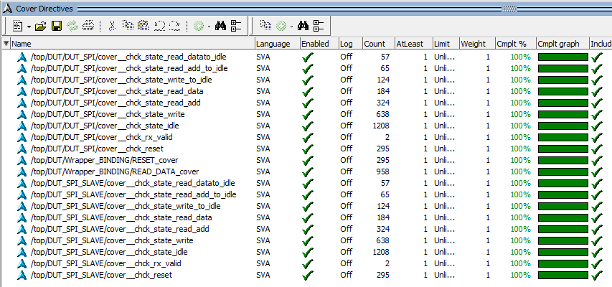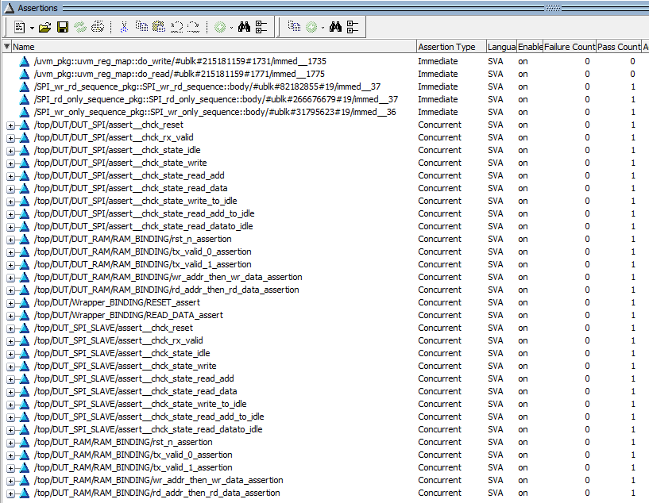

Figure 46: Assertion Coverage

Figure 47: Cover Directives

***4- Verification Plan:***

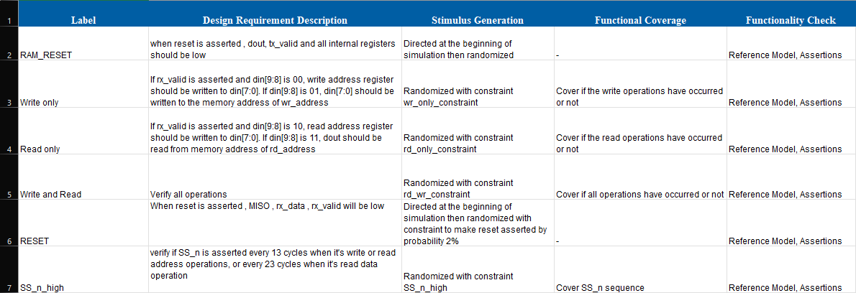

Figure 48: Verification Plan